# Final Deliverable Project Report

|  |  |
| --- | --- |
| Date | 25 November 2022 |
| Team ID | PNT2022TMID08572 |
| Project Name | Project - Inventory Management System  For Retailers |

**TABLE OF CONTENTS**

# INTRODUCTION

* 1. Project Overview

# LITERATURE SURVEY

* 1. Existing problem
  2. References
  3. Problem Statement Definition

# IDEATION & PROPOSED SOLUTION

* 1. Empathy Map Canvas
  2. Ideation & Brainstorming
  3. Proposed Solution
  4. Problem Solution fit

# REQUIREMENT ANALYSIS

* 1. Functional requirement
  2. Non-Functional requirements

# PROJECT DESIGN

* 1. Data Flow Diagrams
  2. Solution & Technical Architecture
  3. User Stories

# PROJECT PLANNING & SCHEDULING

* 1. Sprint Planning & Estimation
  2. Sprint Delivery Schedule
  3. Reports from JIRA

# CODING & SOLUTIONING (Explain the features added in the project along with code)

* 1. Feature 1
  2. Feature 2
  3. Database Schema

# Testing

# Test cases

# User acceptance testing

# RESULTS

* 1. Performance Metrics

# ADVANTAGES & DISADVANTAGE

1. **CONCLUSION**

# FUTURE SCOPE

1. **APPENDIX**

Source Code

# PROJECT REPORT

1. **INTRODUCTION**

# Project Overview:

The inventory stock manager face is to keep a track of how much stock is purchased and how much stock is spent out. The stock admin does not have an easy way to manage the stocks that is purchased and is dispatched out in the organization. Retail inventory management is the process of ensuring you carry merchandise that shoppers want, with neither too little nor too much on hand. By managing inventory, retailers meet customer demand without running out of stock or carrying excess supply At present this is done, where manager has to manually keep the reports in hand and calculate the costs eventually.The admin also does not have any easy way to look at the details and the amount of stock that is being purchased and dispatched. The cost that is spent on the food items is also not known exactly to the college admins.

# LITERATURE SURVEY

# [1] [Hind Benfenatki](https://www.researchgate.net/profile/Hind-Benfenatki), [Catarina Ferreira da Silva](https://www.researchgate.net/profile/Catarina-Ferreira-Da-Silva-2), [Aïcha-Nabila Benharkat](https://www.researchgate.net/profile/Aicha-Nabila-Benharkat), “Cloud Application Development Methodology” IEEE/WIC/ACM International Conference on Web Intelligence (WI 2014)

This paper describes MADONA methodology, and focuses on the requirements expression phase, by describing RIVAL -a Requirement Vocabulary- based on Linked USDL principles. MADONA allows business stake holders to perform the automatic development of business applications; and combines cloud services discovery and composition with service development using cloud platforms, when the discovery process does not return a service meeting the business stakeholder’s requirements. The description of developed services is stored, and the latter are used in the future workflows. MADONA is implemented as “Services Orchestration as a Service.” It uses the “Juju” [11] cloud orchestration tool to deploy cloud services in several IaaS. A cloud orchestration tool is available without the underlying physical resources needed for the deployment of services. It allows us to deploy and compose supplied services abstracting from the technical details, i.e. (i) the management of the dependencies between services, (ii) the deployment of selected services, (iii)

scalable services to a global client base. Therefore, a cloud computing platform was used to develop a mobile application that supports cloud-based services. Eclipse was used as a development environment for the Android application, and as Eclipse offers a Google plugin, it was also used to deploy the application to Google App Engine. Once the development environment was fully configured, it allowed the

creation and deployment of a mobile application: My Notes to the Google App Engine cloud. The results showed that cloud computing could be used as a backend to take some workload off the mobile device. However, My Notes app only characterizes certain

tasks such as storing, retrieving, and deleting taken notes. In the future, it would be useful to test and investigate how a task that requires large computations from the

mobile devices or tasks that are not even possible to be performed on mobile devices, would use the cloud services to benefit mobile phone users.

# [2] Stanley Ewenike, Elhadj Benkhelifa and Claude Chi Belushi, “Cloud Based Collaborative Software Development”

Cloud computing is a technology trend that is changing the IT landscape and changing collaboration [3]. One of its most notable advantage lies in its adaptability to varying contexts of use, its extensibility, as well as, the numerous possibilities and opportunities it presents for all stakeholders to collaborate [37]. However, not unlike most emerging paradigms, mixed feelings trail adoption of the Cloud [4], [5], [38]. For collaborative software development, the benefits include, but are not limited to, cost savings, scalability, agility for business and development peak period needs, motivation for innovation and increased R&D [29]. On the other hand, there are fears about: security issues; vendor lock-in and interoperability

issues, portability issues; automation, performance issues; availability issues; handling uncertainty about: heterogeneity and content type, location of client, bandwidth unpredictability, dynamic workload variations, workflow schedules, architecture and resource optimization; availability and integrity of relevant information within participating teams and systems; context awareness and reproducibility within contexts; amongst others [27], [37], [39]. Some of these challenges and issues listed here are partly inherited since Cloud Computing itself, is a paradigm that leverages a couple of other technologies [40]

# References:

* <https://www.mdpi.com/2227-7390/10/10/1716/pdf-vor>
* <https://ieeexplore.ieee.org/stamp/stamp.jsp?arnumber=9343878>

# Problem Statement Definition :

|  |  |  |  |  |  |
| --- | --- | --- | --- | --- | --- |
| **Problem**  **Statement (PS)** | **I am**  **(Customer)** | **I’m trying to** | **But** | **Because** | **Which makes me feel** |
| PS-1 | Teacher | Buying cable for computer | Specific converters are not available  in shops | Each student has different types of port in laptops  and Pc | Unable to teach students hands-on |
| PS-2 | Youngster | Buying exported cosmetic things | Rarely available in normal shops and  on online | Exporting things will be in limited stock | Couldn’t full fill the wish of using expensive things makes me unhappy. |
| PS-3 | Youngster | Buying exported vehicle accessory | Rarely available in motor shops and  on online | Exporting things will be in limited stock and  take time | Couldn’t full fill the wish of modifying the vehicle. |

# IDEATION & PROPOSED SOLUTION

* 1. **Empathy Map Canvas :**

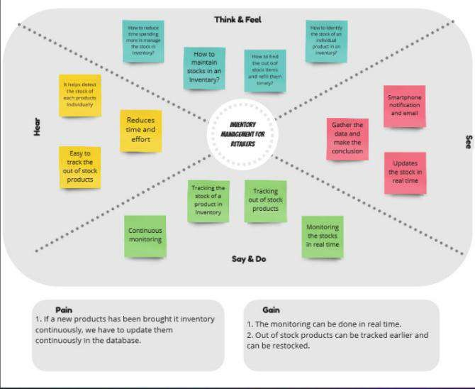

# Ideation & Brainstorming :

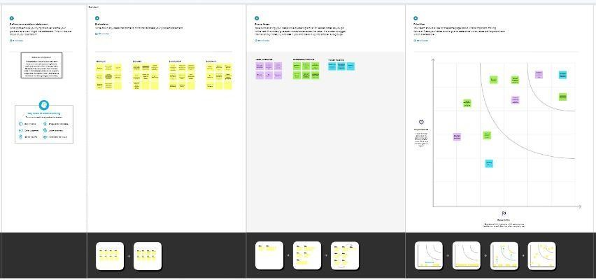

* 1. **Proposed Solution:**

|  |  |  |
| --- | --- | --- |
| **S.No.** | **Parameter** | **Description** |
| 1. | Problem Statement  (Problem to be solved) | * The retailers generally facing issues in   recording the stocks and its threshold limit available.   * The customers are not satisfied with the retailers store since it doesn’t have enough supplements and the deliveries were not made on time. |
| 2. | Idea / Solution description | Hereby we can provide a robust and most  reliable inventory management system by using   * The product availability is tracked daily and an alert system in again kept on to indicate those products which falls below the threshold limit. * All the customers can register their accounts after which they will be given a login credentials which they can use whenever they feel like buying the stocks. * The application allows the customers to know all the present time available stocks and also when the new stock will be available on the store for them to buy. |

|  |  |  |
| --- | --- | --- |
| 3. | Novelty / Uniqueness | Certain machine learning algorithms are  used to predict the seasonal high selling products which can be made available during that time. Prediction of the best selling brand of all certain products based on their popularity, price and customer trust and satisfaction will be implemented. Notifications will be sent to the retailers if any product that the customers have been looking for is not available so that the product can be stocked up soon. |
| 4. | Social Impact / Customer  Satisfaction | The customers will be highly satisfied  since the wasting of time while searching for an unavailable product is reduced. The work load of the retailers will be minimized if the system is automated every day and during every purchase. The customer satisfaction will be improved for getting appropriate response from the retailers and that  too immediately. |

|  |  |  |
| --- | --- | --- |
| 5. | Business Model (Revenue  Model) | Hereby we can provide a robust and most  reliable inventory management system by using:   * ML algorithms for all the prediction   purposes using all the past dataset since datasets are undoubtedly available in huge amounts.   * Can deploy the most appropriate business advertising models. * To establish a loss preventing strategy. * And to ensure the all time, any where availability of products system. |
| 6. | Scalability of the Solution | * Implementation of anyone and anywhere   using system can be helpful for even a commoner to buy the products.   * Daily and Each time purchase updation of   the stock for preventing inventory shrinkage. |

# Problem Solution fit:

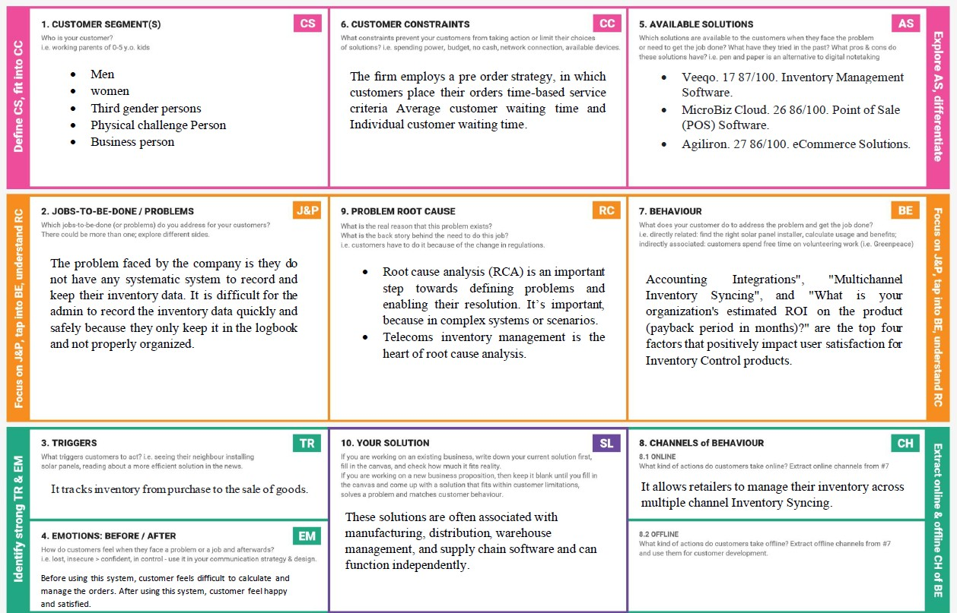

1. **REQUIREMENT ANALYSIS**

# Functional Requirement:

|  |  |  |
| --- | --- | --- |
| 1. **FR No.** | **Functional Requirement (Epic)** | **Sub Requirement (Story / Sub-Task)** |
| FR-1 | User Sign in | Retailers can register with username, password, email,PhoneNumber. |
| FR-2 | User Login | Retailers can access their accounts by logging into the application. |
| FR-3 | Sales Orders | The Companies will Purchase the orders and it will help to check how much Orders are needed. |
| FR-4 | Chatbot | A chat on the webpage to solve user queries and issues. |
| FR-5 | Inventory Management | Inventory is the good and merchandise in store for future use at an right time,right levels and right costs to be  managed. |
| FR-6 | Reports | Automated report generation is the goal software and  report on inventory verification and on inventory forecasting. |
| FR-7 | Database | FIFO,LILO based Database management and Sales administration. |
| FR-8 | Logout | Use logout option after completing Inventory management for retailers. |

# Non-functional Requirements:

Following are the non-functional requirements of the proposed solution.

|  |  |  |
| --- | --- | --- |
| **FR No.** | **Non-Functional Requirement** | **Description** |
| NFR-1 | **Usability** | Inventory management helps companies identify which and how much stock to order at what time. It tracks inventory from purchase to the sale of goods. The practice identifies and responds to trends to ensure there's always enough stock to fulfill customer orders and proper warning of a  shortage. |
| NFR-2 | **Security** | Inventory security is the process of ensuring the safety and optimum management control of stored goods. |
| NFR-3 | **Reliability** | Huge number of stocks are easily determined so  that it can be more reliable inventory management system. |
| NFR-4 | **Performance** | The impact of a inventory management system on supply chain performance that provides less resources effort, more efficient. |

|  |  |  |
| --- | --- | --- |
| NFR-5 | **Availability** | It can be available for all kind of retailers and wholesale business man. |
| NFR-6 | **Scalability** | With a cloud-based, automatic and accurate inventory management software, distributors can effectively reduce costs, minimize waste, meet  customers’ expectations, and predict future  demands |

# 5.PROJECT DESIGN

**5.1 Data Flow Diagrams:**

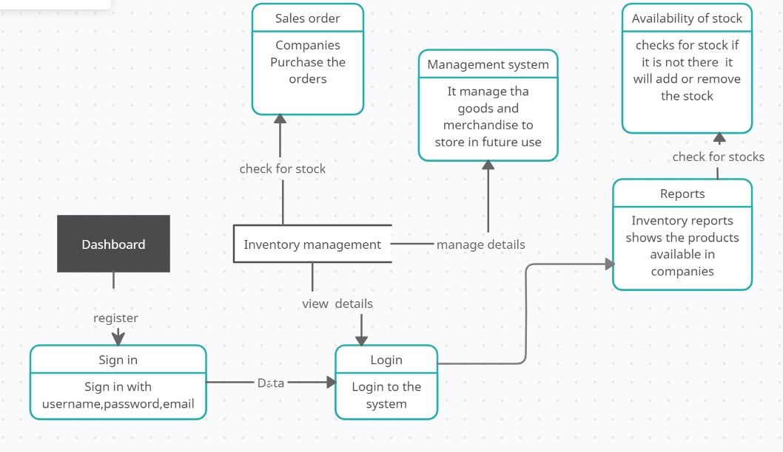

# Solution & Technical Architecture:

Technical architecture involves the development of a technical blueprint regarding the arrangement, interaction, and interdependence of all elements so that system-relevant requirements are met.

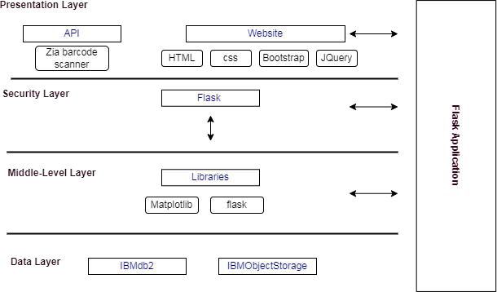



* There was no an insufficient solution available in the many companies during these days. Every process was based on paperwork, human fault rate was high, the process and the tracing the inventory losses were not possible, and there were no efficient logging systems.After the computer age, every process is started to be integrated t into electronic environment. And now we have qualified technology to implement new solutions to these problems.

Example - Solution Architecture Diagram

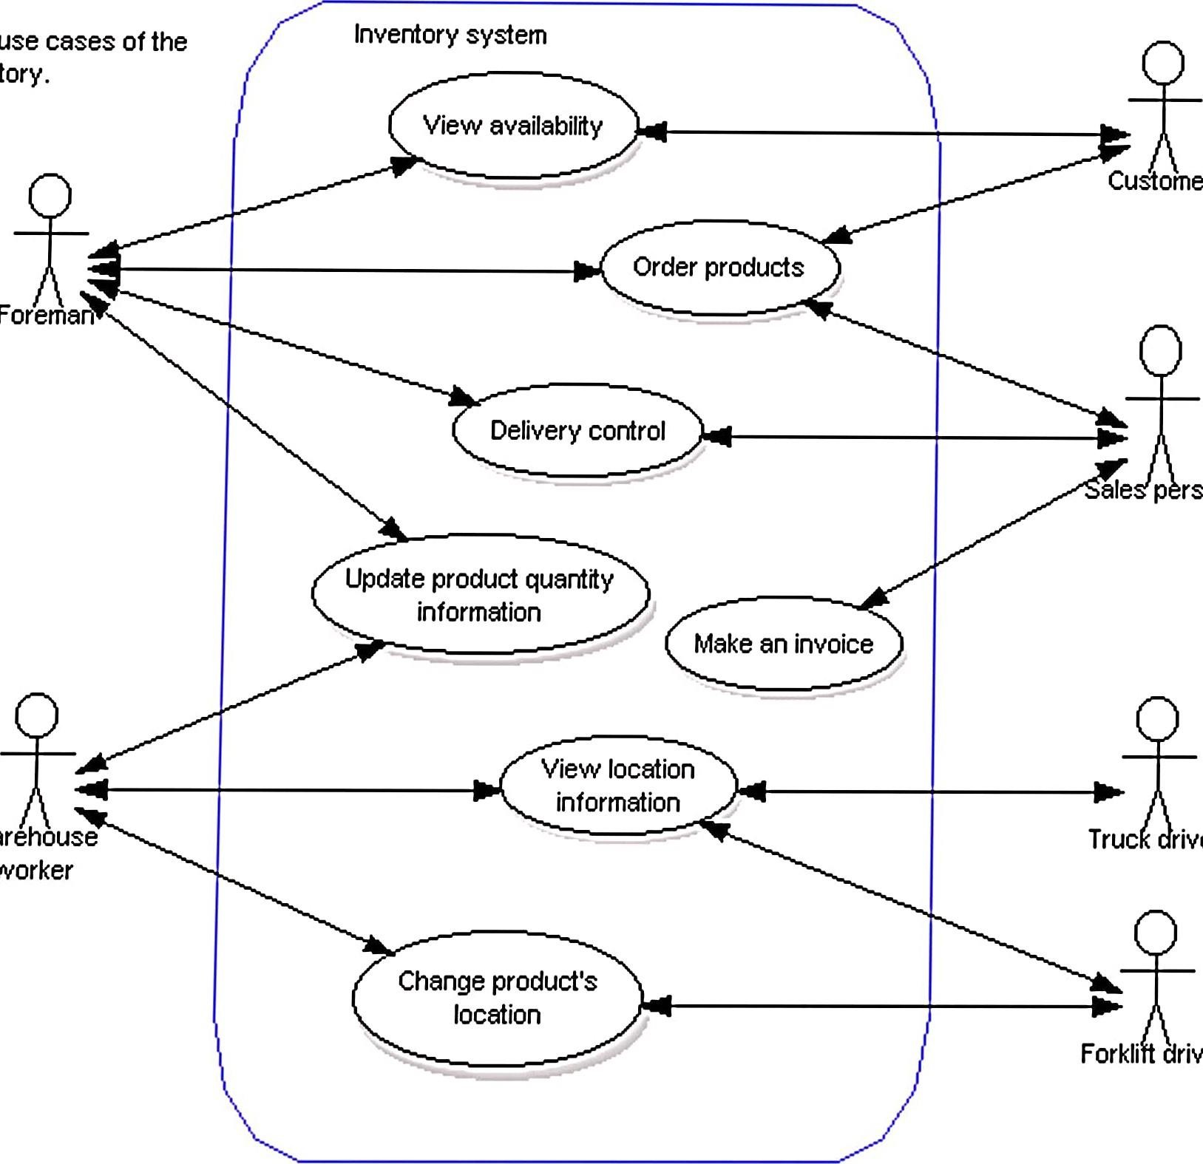

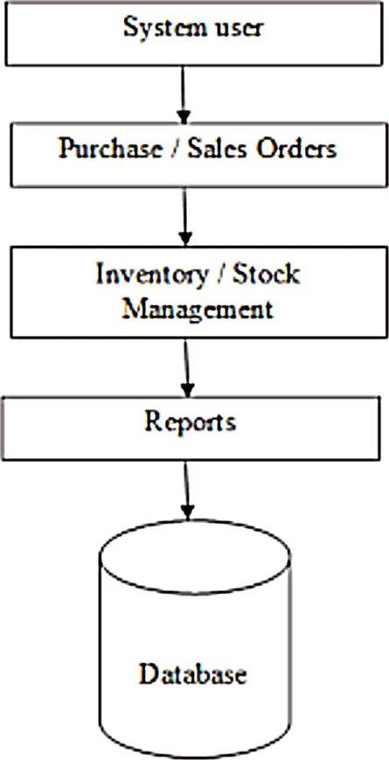.



# User Stories :

|  |  |  |  |  |  |  |
| --- | --- | --- | --- | --- | --- | --- |
| **User Type** | **Functional Requirement**  **(Epic)** | **User Story Number** | **User Story / Task** | **Acceptance criteria** | **Priority** | **Release** |
| Retailer(Web user) | Registration | USN-1 | As a user, I can register for the application by  entering my email, password, and confirming my password. | I will be redirected to login page | High | Sprint-1 |
|  | USN-2 | As a user, I will receive confirmation email  once I have registered for the application | I can receive confirmation  email & click confirm | High | Sprint-1 |
|  | USN-3 | As a user, I can register for the application through google | I can register & access the dashboard with Facebook Login | Low | Sprint-2 |
|  | USN-4 | As a user, I can register for the application  through Gmail | I can verify the OTP number | Medium | Sprint-1 |
|  | Login | USN-5 | As a user, I can log into the application by  entering email & password | I can access my account /  dashboard | High | Sprint-1 |
|  | Dashboard | USN-6 | As a user,I can view inventory management,reports availability of stocks . | Updation can be made  through barcode scanning | High | Sprint -2 |
|  |  | USN-7 | As a user,I can check the low stock details  through alert message | Alert message can be  received by registered mail | High | Sprint -1 |
|  |  | USN-8 | As a user,I can check the total product details | I can view the value of total products in the stock | Medium | Sprint -2 |
|  |  | USN-9 | As a user,I can check the high demand  product details | I can update sales details  of the products | High | Sprint -2 |
|  |  | USN-10 | As a user,I can manage the inventory details. | I can add incoming stock details | High | Sprint -1 |

1. **.PROJECT PLANNING & SCHEDULING**

# 6.1 Sprint Planning & Estimation & Delivery Schedule:

|  |  |  |  |  |  |  |
| --- | --- | --- | --- | --- | --- | --- |
| **Sprint** | **Functional Requirement (Epic)** | **User Story Number** | **User Story / Task** | **Story Points** | **Priority** | **Team Members** |
| Sprint-1 | Registration | USN-1 | As a user, I can register for the application by entering my email, password, and confirming my password. | 13 | High | 3 |
| Sprint-1 | Confirmation | USN-2 | As a user, I will receive confirmation email once I have registered for the application | 13 | High | 1 |
| Sprint-2 | Registration through email | USN-3 | As a user, I can register for the application through Google account | 8 | Low | 2 |
| Sprint-1 | Login | USN-4 | As a user, I can log into the application by entering email & password | 13 | High | 3 |
| Sprint-2 | Dashboard | USN-5 | As a user, I can log in into the application and view the dashboard for Inventory information | 8 | Medium | 3 |
| Sprint-2 | Sales Order | USN-6 | As a user, I can view the stock availability to  sales order | 13 | High |  |
| Sprint-3 | Database | USN-7 | Admin can access, view, modify, update all details of the Inventory | 20 | High | 2 |
| Sprint-4 | Software testing and deployment | USN-8 | As user want to access the application without any drawbacks, we need to test the software before release. | 13 | High | 2 |

Project Tracker, Velocity & Burndown Chart: (4 Marks)

|  |  |  |  |  |  |  |
| --- | --- | --- | --- | --- | --- | --- |
| **Sprint** | **Total Story Points** | **Duration** | **Sprint Start Date** | **Sprint End Date (Planned)** | **Story Points Completed (as on**  **Planned End Date)** | **Sprint Release Date (Actual)** |
| Sprint-1 | 20 | 6 Days | 24 Oct 2022 | 29 Oct 2022 | 20 | 29 Oct 2022 |
| Sprint-2 | 20 | 6 Days | 31 Oct 2022 | 05 Nov 2022 | 20 | 05 Nov 2022 |
| Sprint-3 | 20 | 6 Days | 07 Nov 2022 | 12 Nov 2022 | 20 | 12 Nov 2022 |
| Sprint-4 | 20 | 6 Days | 14 Nov 2022 | 19 Nov 2022 | 20 | 19 Nov 2022 |

Velocity:

Sprint 1(AV) =3.34

Sprint 2(AV) =3.34

Sprint 3(AV) =3.34

Sprint 4(AV) =3.34

* 1. **Reports from JIRA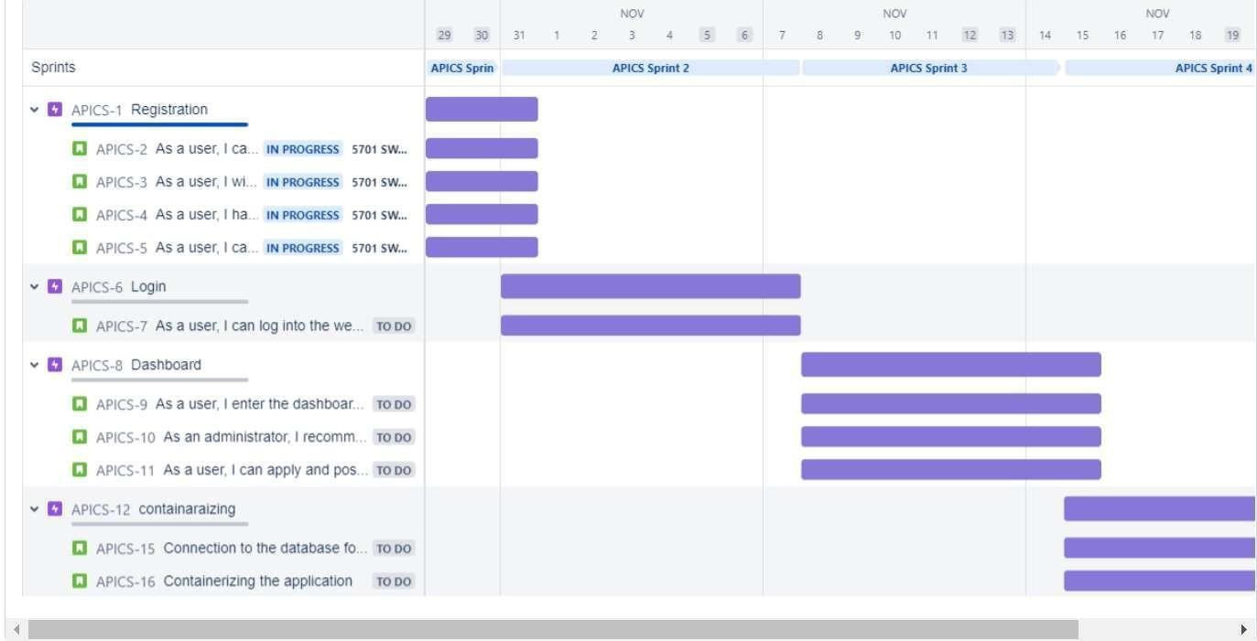:**

# 7.CODING & SOLUTIONING (Explain the features added in the project along with code)

* 1. **Feature 1**

# Self-service On-Demand

This is one of the most essential and significant characteristics of cloud computing. This means that cloud computing enables clients to regularly monitor the abilities, allotted network storage, and server uptime. Therefore, it is one of the most fundamental features of cloud computing that helps clients control various computing abilities as per their requirements.

# Resources Pooling

This is also a fundamental characteristic of cloud computing. Pooling resources means that a cloud service provider can distribute resources for more than one client and provide them with different services according to their needs. Resource Pooling is a multi-client plan useful for data storing, bandwidth services and data processing services. The provider administers the data stored in real-time without conflicting with the need for data.

# Easy Maintenance

This is one of the best cloud characteristics. Cloud servers are easy to maintain with low to almost zero downtime. Cloud Computing powered resources undergo several updates frequently to optimize their capabilities and potential. The updates are more viable with the devices and perform quicker than the previous versions.

# Economical

This kind of service is economical as it efficiently reduces IT costs and data storage expenditure. Moreover, most cloud computing services are free. Even if there are paid plans, it's only to expand storage capacity, and these costs are often very nominal. This is a massive advantage of using cloud computing services.

# Rapid Elasticity and Scalability

The best part of using cloud storage is that it can easily handle all the workload and data load concerning storage. Furthermore, as it is fully automated, businesses and organizations can save heavily on manual labor and technical staffing as cloud services are elastic, scalable and automated. This is one of the significant advantages of using cloud services.

# API Features:

* H TTPSISSL certificates Programming cheat sheets
* Try for free: Red Hat Learning Subscription
* eBook: An introduction to programming with Bash Bash Shell Scripting Cheat Sheet
* eBook: Modernizing Enterprise Java The gold standard for the web is HTTPS using

# Cross-origin resource sharing

CORS is a browser-specific security policy preflight check. If your APIserver is not in the same domain as the requesting client's domain, you will need to deal with CORS. For example, if your server is running onapi.domain-a.com and gets a client request from domain-b.com, Coarsens an HTTP precheck request to see if your API service will accept client-side requests from the client's domain.

# Authentication and JSON Web Tokens

There are several approaches to validate an authenticated user in your API, but one of the best ways is to use JSON Web Tokens (JWT). These tokens are signed using various types of well-known cryptographic libraries. When a client logs in, an identity- management service provides the client with a JWT. The client can then use this token to make requests to the API. The API has access to a public key or a secret that it uses to verify the token. There are several libraries available to help verify tokens, including honeytoken. For more information about JWT and the libraries that support it in every language, check out JWT.io.

# Authorizations and scopes

Authentication (or identity verification) is important, but so isauthorization, i.e., does the verified client have the privilege to execute this request? This is where scopes are valuable. When the client authenticates with the identity management server and a JWT token is created, having the identity management service provide the scopes for the given authenticated client can enable the API service to determine if this verified client request can be performed without having to perform an additional costly lookup to an access control list.

**7.2 Feature 2:**

# Docker Features:

1. **Faster and Easier configuration:**

It is one of the key features of Docker that helps you in configuring the system in a faster and easier manner. Due to this feature, codes can be deployed in less time and with fewer efforts. The infrastructure is not linked with the environment of the application as Docker is used with a wide variety of environments.

# Application isolation:

Docker provides containers that are used to run applications in an isolated environment. Since each container is independent, Docker can execute any kind of application.

# Increase in productivity:

It helps in increasing productivity by easing up the technical configuration and rapidly deploying applications. Moreover, it not only provides an isolated environment to execute applications, but it reduces the resources as well.

# Swarm:

Swarm is a clustering and scheduling tool for Docker containers. At the front end, it uses the Docker API, which helps us to use various tools to control it. It is a self-organizing group of engines that enables pluggable backends.

# Service:

Services is a list of tasks that specifies the state of a container inside a cluster. Each task in the Services lists one instance of a container that should be running, while Swarm schedules them across the nodes.

# Kubernetes Features:

* 1. Auto-scaling. Automatically scale containerized applications and their resources up or down based on usage
  2. Lifecycle management. Automate deployments and updates with the ability to:
     1. Rollback to previous versions
     2. Pause and continue a deployment
  3. Declarative model. Declare the desired state, and K8s works in the background to maintain that state and recover from any failures.

# Database Schema:

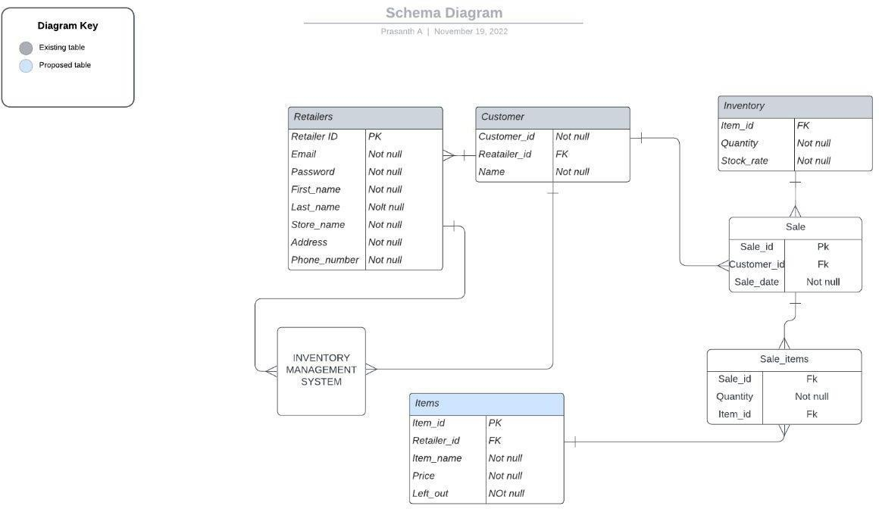

1. **TESTING**

# Test Cases:

* + 1. Verify that user is already registered or not
    2. Verify the Ul elements in Login/Signup popup
    3. Verify user can log into application with Valid credentials
    4. Verify that categories of actions(adding items,customer,sale,etc) are shown in homepage
    5. Verify that actions is displayed in homepage
    6. Verify that when clicked on actions it is redirected to correct page
    7. Verify that actions are correctly performed

# User Acceptance Testing:

The purpose of this documents to briefly explain the test coverage and open issues of the Inventory management system for retailers Application project at the time of the release User Acceptance Testing (UAT). This report shows the number of resolved or closed bugs at each severity level, and how they were resolved

* + 1. Defect Analysis

This report shows the number of resolved or closed bugs at each severity level, and how they were resolved

* + 1. Test Case Analysis

This report shows the number of test cases that have passed,failed, and untested

# RESULTS

* 1. **Performance Metrics:**

The application performance index, or Apex score, has become an industry standard for tracking the relative performance of an application. It works by specifying a goal for how long a specific web request or transaction should take. Those transactions are then bucketed into satisfied (fast), tolerating (sluggish), too slow, and failed requests. A simple math formula is then applied to provide a score from 0 to 1.

# HOME PAGE:

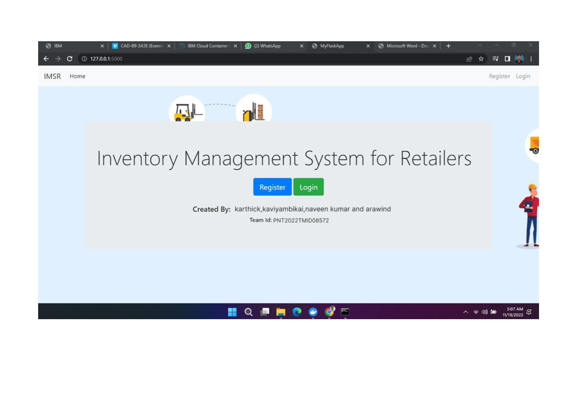

**REGISTER PAGE**

# 

**LOGIN PAGE :**

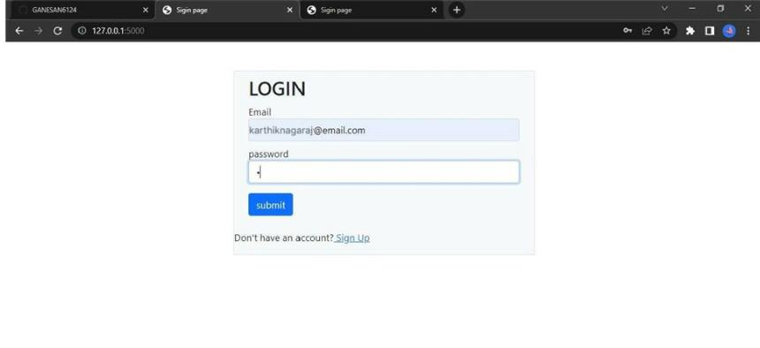

**DASHBOARD**

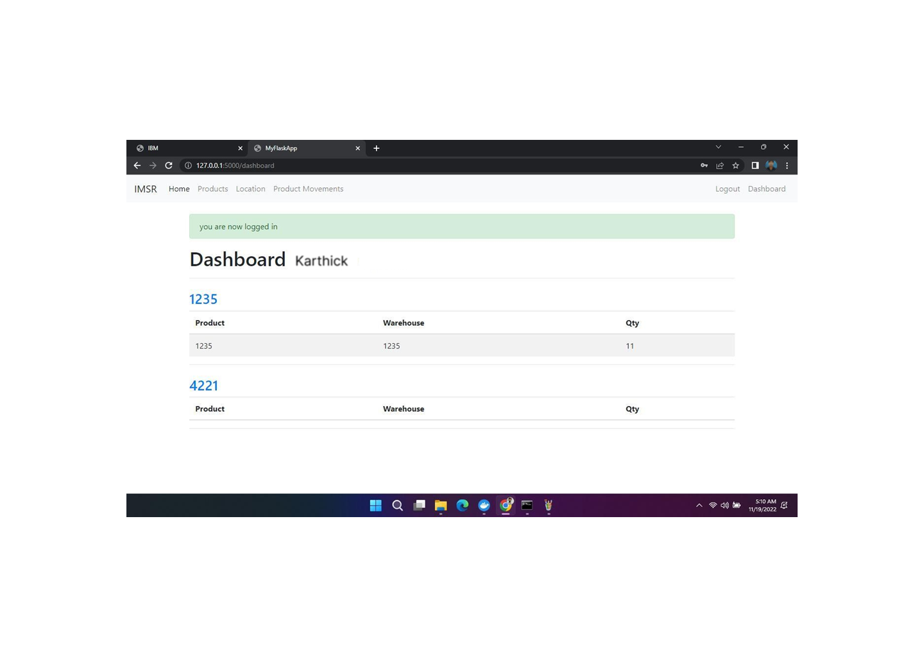

# PRODUCTS PAGE

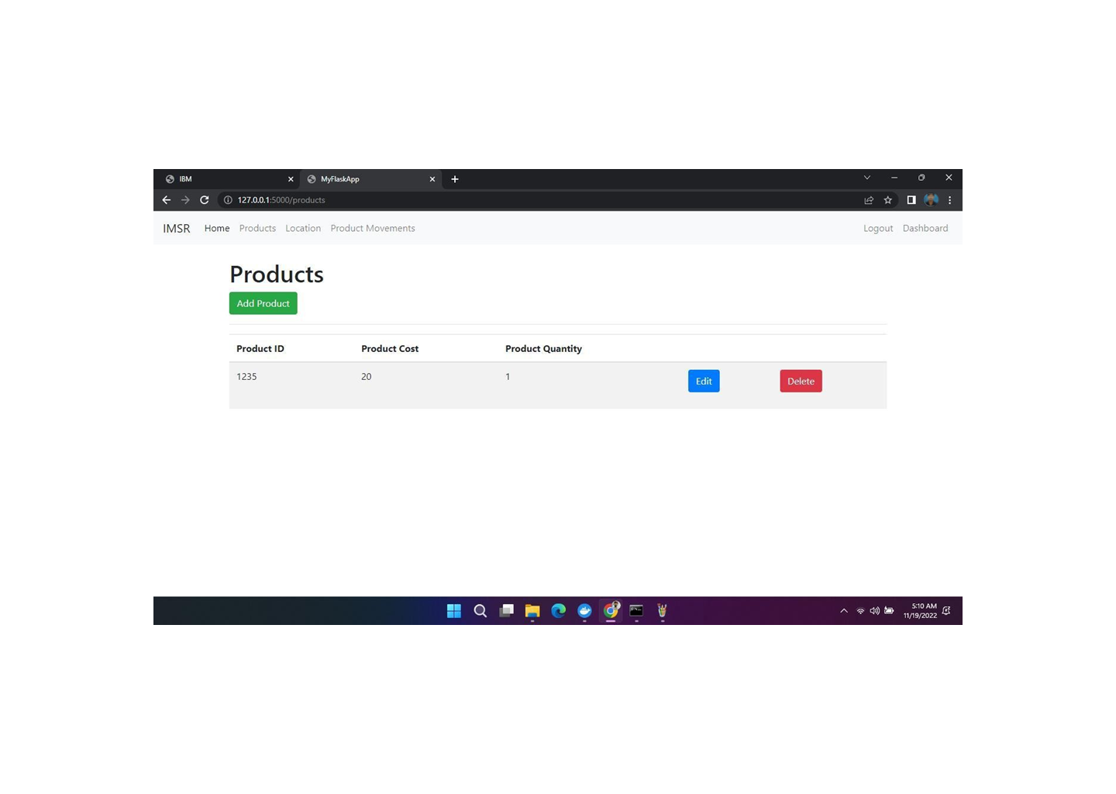

**LOCATION PAGE**

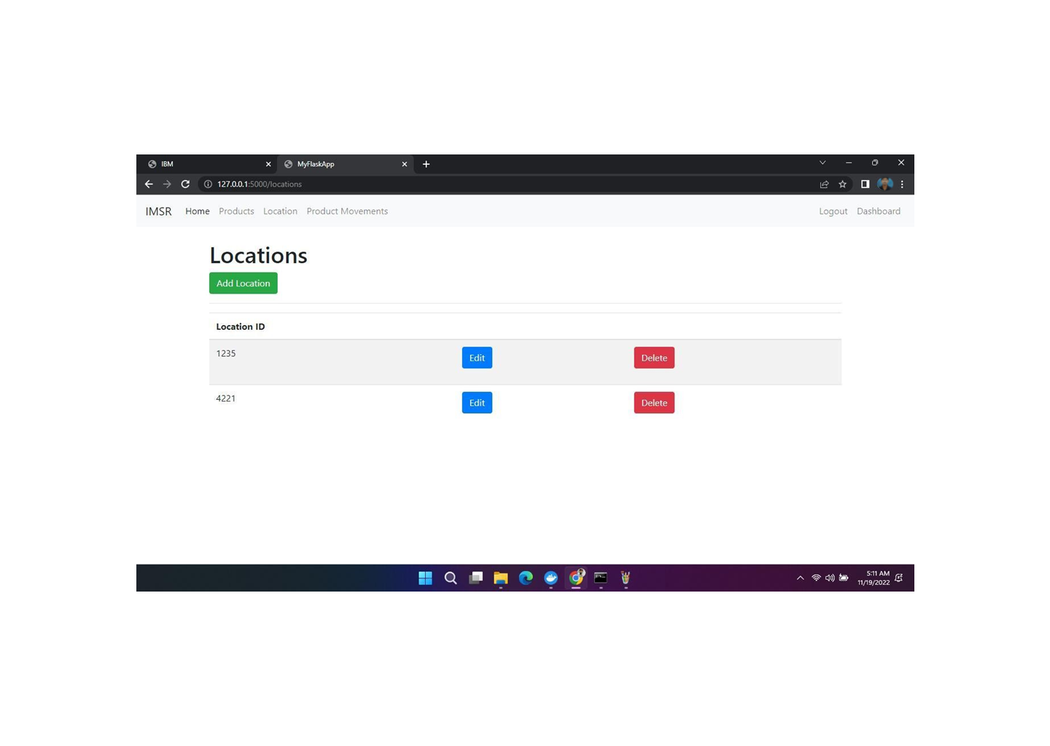

# ADD PRODUCTS PAGE

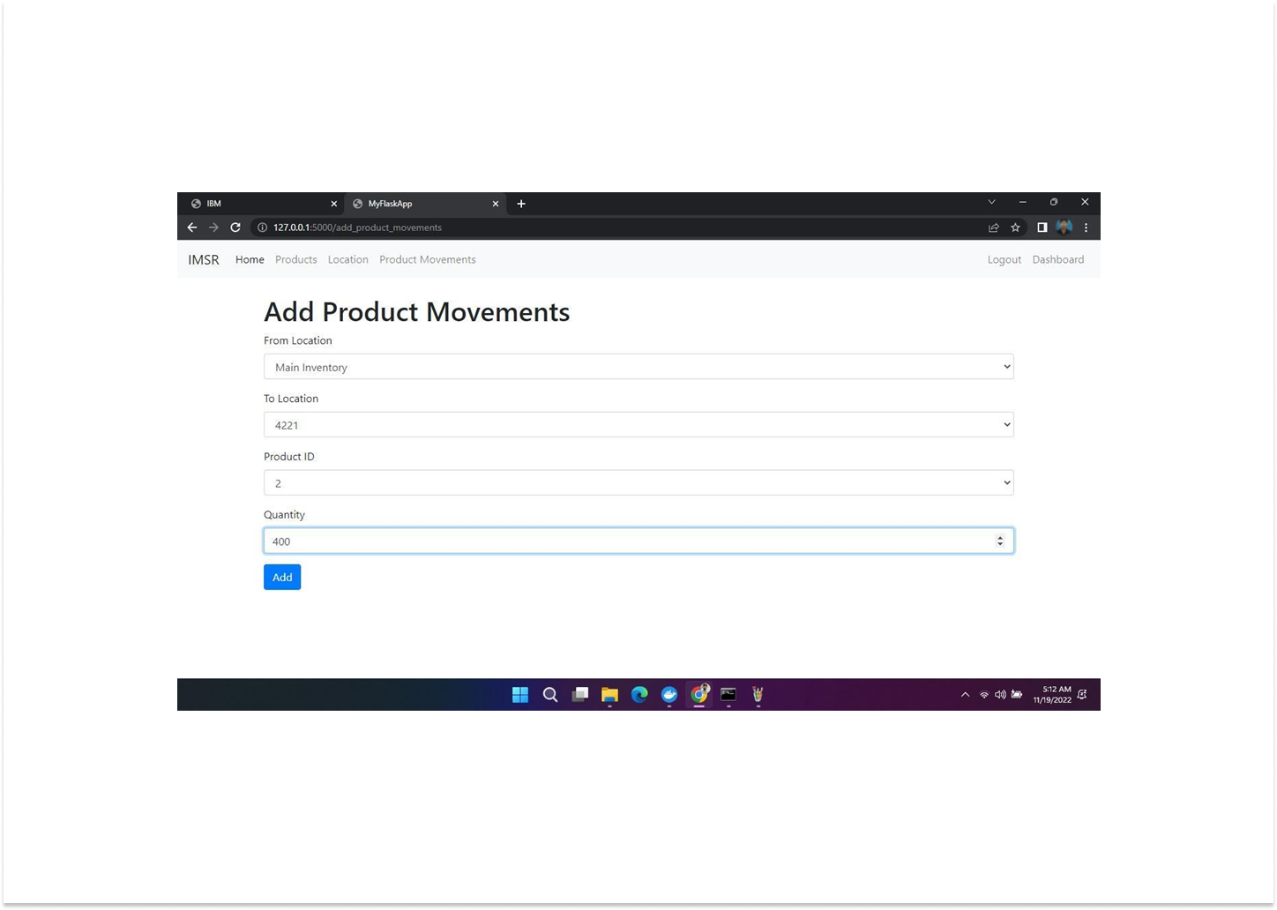

1. **ADVANTAGES & DISADVANTAGES Advantages:**
2. **It leads to a more organized warehouse:** with the aid of a good inventory management system, you can easily organize your warehouse. If your warehouse is not organized, you will find it very difficult to manage your inventory. A lot of businesses choose to optimize their warehouse by putting the items that have the highest sales together in a place that is easy to access in the warehouse. This ultimately helps to speed up order fulfilment and keeps clients happy.
3. **Improves efficiency and productivity:** inventory management devices like bar code scanners and inventory management software can help to greatly increase the efficiency and productivity of a business. They do this by eliminating the manual way of doing things thus allowing employees to do other more important things for the business.
4. **Schedule maintenance:** once you get hold of a new appliance, you can begin to schedule

routine and preventative maintenance, issue work order to your staff and track that the maintenance was actually carried out. This will help to elongate the life span of that particular asset.

# Disadvantages:

1. **Impersonal touch:** Another disadvantage of inventory management is a lack of personal touch. Large supply chain management systems make products more accessible across the globe and most provide customer service support in case of difficulty, but the increase in infrastructure can often mean a decrease in the personal touch that helps a company to stand out above the rest. For instance, the sales manager of a small manufacturing company that sells plumbing supplies to local plumbers can throw in an extra box of washers or elbows at no charge to the customer without raising any alarms. This is done for the sake of customer relations and often makes the customer feel like he is special. While free materials can also be provided under inventory management, processing time and paper work make obtaining the material feel more like a chore for the customer or even an entitlement.
2. **Production problem:** Even though inventory management can reveal to you the amount of stock you have at hand and the amount that you have sold off, it can also hide production problems that could lead to customer service disasters. Since the management places almost all of its focus on inventory management to the detriment of quality control, broken or incorrect items that would normally be discarded are shipped along with wholesome items.
3. **Increased space is need to hold the inventory:** In order to hold inventory, you will need to have space so unless the goods you deal in are really small in size, then you will need a warehouse to store it. In addition, you will also need to buy shelves and racks to store your goods, forklifts to move around the stock and of course staff. The optimum level of inventory for a business could still be a lot of goods and they will need space to be stored in and in some cases additional operational costs to manage the inventory. This will in turn increase cost and impact negatively on the amount of profit the business makes.

# 11.CONCLUSION

We proposed an application for inventory management system task. This application facilitates the opportunities of inventory management process as well as it allows the use of a variety of actions like adding customers,items,sales,inventory and view customers,inventory,items and sale. Moreover, we also contribute making publicly available a new dataset containing inventory management. Future directions of our work will focus on performing a more exhaustive evaluation considering a greater amount of methods and data as well as a comprehensive evaluation of the impact of inventory management

# 12.FUTURE SCOPE

The future is and will remain unknown to us , but fact is there is a issue of maintaining inventory in the market world, the inventory management system will exist and will grow in proportionate with demand

# 13.APPENDIX

13.1 Source Code: Styles: Style.css:

*,

*:before,

*:after {

box-sizing: border-box; margin: 0; padding: 0;

}

body {

font-family: 'Open Sans', Helvetica, Arial, sans-serif; background-image: url("../images/bg1.png"); background-repeat: no-repeat;

background-attachment: fixed; background-size: cover;

}

input, button {

border: none; outline: none; background: none;

font-family: 'Open Sans', Helvetica, Arial, sans-serif;

}

.tip {

font-size: 20px;

margin: 40px auto 50px; text-align: center;

}

.cont {

border-radius: 20px; overflow: hidden; position: relative; width: 900px; height: 800px; margin: 0 auto 100px;

background: rgba(69, 191, 195, 0.7);

box-shadow:-10px -10px 15px rgba(255, 255, 255, 0.3), 10px 10px 15px rgba(70, 70, 70, 0.15), inset -10px -

10px 15px rgba(255, 255, 255, 0.3), inset 10px 10px 15px rgba(70, 70, 70, 0.15);

}

.form {

position: relative; width: 640px; height: 100%; padding: 50px 30px 0;

}

.sub-cont { overflow: hidden; position: absolute; left: 640px; top: 0;

width: 900px; height: 100%; padding-left: 260px; button {

display: block; margin: 0 auto; width: 260px; height: 36px; border-radius: 30px; color: #fff;

font-size: 15px; cursor: pointer;

}

.img {

overflow: hidden; z-index: 2; position: absolute; left: 0; top: 0;

width: 260px; height: 100%; padding-top: 360px;

}

.img:before { content: ''; position: absolute; right: 0; top: 0;

width: 900px; height: 100%;

background-image: url("../images/bg2.png"); opacity: .8; background-size: cover;

img:after { content: ''; position: absolute; left: 0; top: 0;

width: 100%;

height: 100%;

background: rgba(0, 0, 0, 0.6);

}

.img text { z-index: 2; position: absolute; left: 0; top: 50px; width: 100%;

padding: 0px 20px; text-align: center; color: #3cb371;

}

.img text h2 {

margin-bottom: 10px; font-weight: normal;

}

.img text p { font-size: 14px; line-height: 1.5;

}

.img btn { overflow: hidden; z-index: 2; position: relative;

width: 100px; height: 36px; margin: 0 auto; background: transparent; color: #fff;

text-transform: uppercase; font-size: 15px; cursor: pointer;

}

.img btn:hover{ color:green;

}

.img btn:after { content: ''; z-index: 2;

/* position: absolute; */ left: 0; top: 0;

width: 100%;

height: 100%;

border: 2px solid #fff; border-radius: 30px;

}

.img btn span { position: absolute; left: 0; top: 0;

display: -webkit-box; display: flex; border-radius: 30px;

-webkit-box-pack: center; justify-content: center;

-webkit-box-align: center; align-items: center;

width: 100%;

height: 100%; color:white; background:#dc0b96ca;

/* margin-top: 40px; margin-bottom: 20px; text-transform: uppercase; */

}

.img btn span:hover{ background: #186023da;

}

h2 {

color: black; width: 100%; font-size: 36px; text-align: center;

}

label {

display: block; width: 260px; margin: 25px auto 0; text-align: center;

}

label span {

font-size: 18px; color: #c71585; text-transform: uppercase;

}

input {

display: block; color:#4b0082; width: 100%;

margin-top: 5px; padding-bottom: 5px; font-size: 25px; border-bottom: 1px solid rgba(0, 0, 0, 0.4); text-align: center;

}

.forgot-pass { margin-top: 15px; text-align: center; font-size: 12px; color: #cfcfcf;

}

.submit {

margin-top: 40px; margin-bottom: 20px; background: #dc0b96ca; text-transform: uppercase;

}

.submit:hover{ background: #186023da;

}

.fb-btn {

border: 2px solid #d3dae9; color: #8fa1c7;

}

.fb-btn span {

font-weight: bold; color: #455a81;

}

Templates: Login.html

<html>

<head>

<link rel="stylesheet" href={{url_for('static', filename='styles/style.css')}}>

</head>

<body>

<br>

<br>

<div class="cont">

<i>

<div class="form sign-in">

<h2>Inventory</br>Management System</br></br></h2>

<p style="color:{{colour}};text-align:center;">{{status}}</p>

</br></br>

<form action="/" autocomplete="ON" method="POST">

<label>

<span>Email</span>

<input type="email" name="email" required/>

</label>

</br></br>

<label>

<span>Password</span>

<input type="password" name="password" required/>

</label>

</br></br>

<button type="submit" class="submit">Sign In</button>

</form>

</div>

<div class="sub-cont">

<div class="img">

<div class="img text m--up">

<h3>Don't have an account? Please Sign up!<h3>

</div>

<div class="img btn">

<a href="/signup"><span>SignUp</span></a>

</div>

</div>

</div>

</i>

</div>

</body>

</html>

Signup.html

<html>

<head>

<link rel="stylesheet" href={{url_for('static', filename='styles/style.css')}}>

</head>

<body>

<br>

<br>

<div class="cont">

<i>

<div class="form sign-in">

<h2>Create your Account</h2>

</br>

<p style="color:{{colour}};text-align:center;">{{status}}</p>

<form action="/signup" autocomplete="ON" method="POST">

<label>

<span>Email</span>

<input type="email" name="email" required/>

</label>

<label>

<span>First Name</span>

<input type="text" name="first_name" required/>

</label>

<label>

<span>Last Name</span>

<input type="text" name="last_name" required/>

</label>

<label>

<span>Password</span>

<input type="password" name="password" required/>

</label>

<label>

<span>Store Name</span>

<input type="text" name="store_name" required/>

</label>

<label>

<span>Address</span>

<input type="text" name="address" required/>

</label>

<label>

<span>Phone Number</span>

<input type="text" name="phone_number" required/>

</label>

<button type="submit" class="submit">Sign Up</button>

</form>

</div>

<div class="sub-cont">

<div class="img">

<div class="img text m--up">

<h3>If you already has an account, just sign in.<h3>

</div>

<div class="img btn">

<a href="/"><span>Login</span></a>

</div>

</div>

</div>

</i>

</div>

</body>

</html>

Inex.html

<!DOCTYPE html>

<html :class="{ 'theme-dark': dark }" x-data="data()" lang="en">

<head>

<meta charset="UTF-8" />

<meta name="viewport" content="width=device-width, initial-scale=1.0" />

<title>Inventory Management</title>

<link href="[https://fonts.googleapis.com/css2?family=Inter:wght@400;500;600;700;800&displ](https://fonts.googleapis.com/css2?family=Inter%3Awght%40400%3B500%3B600%3B700%3B800&display=swap) [ay=swap](https://fonts.googleapis.com/css2?family=Inter%3Awght%40400%3B500%3B600%3B700%3B800&display=swap)" rel="stylesheet"

/>

<link rel="stylesheet" href={{url_for('static', filename='styles/tailwind_output.css')}} />

<script src="[https://cdn.jsdelivr.net/gh/alpinejs/alpine@v2.x.x/dist/alpine.min.js"](https://cdn.jsdelivr.net/gh/alpinejs/alpine%40v2.x.x/dist/alpine.min.js) defer

></script>

<script src="{{url_for('static', filename='js/init-alpine.js')}}"></script>

<link rel="stylesheet" href="https://cdnjs.cloudflare.com/ajax/libs/Chart.js/2.9.3/Chart.min.css"

/>

<script src="https://cdnjs.cloudflare.com/ajax/libs/Chart.js/2.9.3/Chart.min.js" defer

></script>

<script src="{{url_for('static', filename='js/charts-lines.js')}}" defer></script>

<script src="{{url_for('static', filename='js/charts-pie.js')}}" defer></script>

</head>

<body>

<div

class="flex h-screen bg-gray-50 dark:bg-gray-900"

:class="{ 'overflow-hidden': isSideMenuOpen }"

>

<!-- Desktop sidebar -->

<aside

class="z-20 hidden w-64 overflow-y-auto bg-white dark:bg-gray-800 md:block flex- shrink-0"

>

<div class="py-4 text-gray-500 dark:text-gray-400">

<a

class="ml-6 text-lg font-bold text-gray-800 dark:text-gray-200" href="#"

>

Inventory Management

</a>

<ul class="mt-6">

<li class="relative px-6 py-3">

<span

class="absolute inset-y-0 left-0 w-1 bg-purple-600 rounded-tr-lg rounded-br-lg" aria- hidden="true"

></span>

<a

class="inline-flex items-center w-full text-sm font-semibold text-gray-800 transition-colors duration- 150 hover:text-gray-800 dark:hover:text-gray-200 dark:text- gray-100"

href="/dashboard"

>

<svg

class="w-5 h-5" aria-hidden="true" fill="none"

stroke-linecap="round" stroke-linejoin="round" stroke-width="2"

viewBox="0 0 24 24" stroke="currentColor"

>

<path

d="M3 12l2-2m0 0l7-7 7 7M5 10v10a1 1 0 001 1h3m10-11l2 2m-2-2v10a1 1 0 01-1 1h-

3m-6 0a1 1

0 001-1v-4a1 1 0 011-1h2a1 1 0 011 1v4a1 1 0 001 1m-6 0h6"

></path>

</svg>

<span class="ml-4">Dashboard</span>

</a>

</li>

</ul>

<ul>

<li class="relative px-6 py-3">

<button

class="inline-flex items-center justify-between w-full text-sm font-semibold transition-colors duration- 150 hover:text-gray-800 dark:hover:text-gray-200" @click="togglePagesMenuCustomer" aria-haspopup="true"

>

<span class="inline-flex items-center">

<svg

class="w-5 h-5" aria-hidden="true" fill="none"

stroke-linecap="round" stroke-linejoin="round" stroke-width="2" viewBox="0 0 24 24" stroke="currentColor"

>

<path

d="M4 5a1 1 0 011-1h14a1 1 0 011 1v2a1 1 0 01-1 1H5a1 1 0 01-1-1V5zM4 13a1 1 0

011-1h6a1 1

0 011 1v6a1 1 0 01-1 1H5a1 1 0 01-1-1v-6zM16 13a1 1 0 011-1h2a1 1 0 011 1v6a1 1 0

01-1 1h-2a1 1 0 01-1-1v-

6z"

></path>

</svg>

<span class="ml-4">Customers</span>

</span>

<svg

class="w-4 h-4" aria-hidden="true" fill="currentColor" viewBox="0 0 20 20"

>

<path

fill-rule="evenodd"

d="M5.293 7.293a1 1 0 011.414 0L10 10.586l3.293-3.293a1 1 0 111.414 1.414l-4 4a1 1

0 01-1.414

0l-4-4a1 1 0 010-1.414z"

clip-rule="evenodd"

></path>

</svg>

</button>

<template x-if="isPagesMenuOpenCustomer">

<ul

x-transition:enter="transition-all ease-in-out duration-300" x-transition:enter- start="opacity-25 max-h-0"

x-transition:enter-end="opacity-100 max-h-xl"

x-transition:leave="transition-all ease-in-out duration-300" x-transition:leave- start="opacity-100 max-h-xl"

x-transition:leave-end="opacity-0 max-h-0"

class="p-2 mt-2 space-y-2 overflow-hidden text-sm font-medium text-gray-500 rounded-md shadow- inner bg-gray-50 dark:text-gray-400 dark:bg-gray-900"

aria-label="submenu"

>

<li

class="px-2 py-1 transition-colors duration-150 hover:text-gray-800 dark:hover:text-gray- 200"

>

<a class="w-full" href="/add_customer">Add customer</a>

</li>

<li

class="px-2 py-1 transition-colors duration-150 hover:text-gray-800 dark:hover:text-gray- 200"

>

<a class="w-full" href="/view_customer">View customer</a>

</li>

</ul>

</template>

</li>

<li class="relative px-6 py-3">

<button

class="inline-flex items-center justify-between w-full text-sm font-semibold transition-colors duration- 150 hover:text-gray-800 dark:hover:text-gray-200" @click="togglePagesMenuItem" aria-haspopup="true"

>

<span class="inline-flex items-center">

<svg

class="w-5 h-5" aria-hidden="true" fill="none"

stroke-linecap="round" stroke-linejoin="round" stroke-width="2" viewBox="0 0 24 24" stroke="currentColor"

>

<path

d="M4 5a1 1 0 011-1h14a1 1 0 011 1v2a1 1 0 01-1 1H5a1 1 0 01-1-1V5zM4 13a1 1 0

011-1h6a1 1

0 011 1v6a1 1 0 01-1 1H5a1 1 0 01-1-1v-6zM16 13a1 1 0 011-1h2a1 1 0 011 1v6a1 1 0

01-1 1h-2a1 1 0 01-1-1v-

6z"

></path>

</svg>

<span class="ml-4">Items</span>

</span>

<svg

class="w-4 h-4" aria-hidden="true" fill="currentColor" viewBox="0 0 20 20"

>

<path

fill-rule="evenodd"

d="M5.293 7.293a1 1 0 011.414 0L10 10.586l3.293-3.293a1 1 0 111.414 1.414l-4 4a1 1

0 01-1.414

0l-4-4a1 1 0 010-1.414z"

clip-rule="evenodd"

></path>

</svg>

</button>

<template x-if="isPagesMenuOpenItem">

<ul

x-transition:enter="transition-all ease-in-out duration-300" x-transition:enter- start="opacity-25 max-h-0"

x-transition:enter-end="opacity-100 max-h-xl"

x-transition:leave="transition-all ease-in-out duration-300" x-transition:leave- start="opacity-100 max-h-xl"

x-transition:leave-end="opacity-0 max-h-0"

class="p-2 mt-2 space-y-2 overflow-hidden text-sm font-medium text-gray-500 rounded-md shadow- inner bg-gray-50 dark:text-gray-400 dark:bg-gray-900"

aria-label="submenu"

>

<li

class="px-2 py-1 transition-colors duration-150 hover:text-gray-800 dark:hover:text-gray- 200"

>

<a class="w-full" href="/add_item">Add Item</a>

</li>

<li

class="px-2 py-1 transition-colors duration-150 hover:text-gray-800 dark:hover:text-gray- 200"

>

<a class="w-full" href="/view_item">View Item</a>

</li>

</ul>

</template>

</li>

<li class="relative px-6 py-3">

<button

class="inline-flex items-center justify-between w-full text-sm font-semibold transition-colors duration- 150 hover:text-gray-800 dark:hover:text-gray-200" @click="togglePagesMenuInventory" aria-haspopup="true"

>

<span class="inline-flex items-center">

<svg

class="w-5 h-5" aria-hidden="true" fill="none"

stroke-linecap="round" stroke-linejoin="round" stroke-width="2" viewBox="0 0 24 24" stroke="currentColor"

>

<path

d="M4 5a1 1 0 011-1h14a1 1 0 011 1v2a1 1 0 01-1 1H5a1 1 0 01-1-1V5zM4 13a1 1 0

011-1h6a1 1

0 011 1v6a1 1 0 01-1 1H5a1 1 0 01-1-1v-6zM16 13a1 1 0 011-1h2a1 1 0 011 1v6a1 1 0

01-1 1h-2a1 1 0 01-1-1v-

6z"

></path>

</svg>

<span class="ml-4">Inventory</span>

</span>

<svg

class="w-4 h-4" aria-hidden="true" fill="currentColor" viewBox="0 0 20 20"

>

<path

fill-rule="evenodd"

d="M5.293 7.293a1 1 0 011.414 0L10 10.586l3.293-3.293a1 1 0 111.414 1.414l-4 4a1 1

0 01-1.414

0l-4-4a1 1 0 010-1.414z"

clip-rule="evenodd"

></path>

</svg>

</button>

<template x-if="isPagesMenuOpenInventory">

<ul

|  |  |  |  |
| --- | --- | --- | --- |
| x-transition:enter="transition-all | ease-in-out | duration-300" | x-transition:enter- |
| start="opacity-25 max-h-0"  x-transition:enter-end="opacity-100 | max-h-xl" |  |  |
| x-transition:leave="transition-all | ease-in-out | duration-300" | x-transition:leave- |
| start="opacity-100 max-h-xl" |  |  |  |

x-transition:leave-end="opacity-0 max-h-0"

class="p-2 mt-2 space-y-2 overflow-hidden text-sm font-medium text-gray-500 rounded-md shadow- inner bg-gray-50 dark:text-gray-400 dark:bg-gray-900"

aria-label="submenu"

>

<li

class="px-2 py-1 transition-colors duration-150 hover:text-gray-800 dark:hover:text-gray- 200"

>

<a class="w-full" href="/add_inventory">Add Inventory</a>

</li>

<li

class="px-2 py-1 transition-colors duration-150 hover:text-gray-800 dark:hover:text-gray- 200"

>

<a class="w-full" href="/view_inventory">View Inventory</a>

</li>

</ul>

</template>

</li>

<li class="relative px-6 py-3">

<button

class="inline-flex items-center justify-between w-full text-sm font-semibold transition-colors duration- 150 hover:text-gray-800 dark:hover:text-gray-200" @click="togglePagesMenuSale" aria-haspopup="true"

>

<span class="inline-flex items-center">

<svg

class="w-5 h-5" aria-hidden="true" fill="none"

stroke-linecap="round" stroke-linejoin="round" stroke-width="2" viewBox="0 0 24 24" stroke="currentColor"

>

<path

d="M4 5a1 1 0 011-1h14a1 1 0 011 1v2a1 1 0 01-1 1H5a1 1 0 01-1-1V5zM4 13a1 1 0

011-1h6a1 1

0 011 1v6a1 1 0 01-1 1H5a1 1 0 01-1-1v-6zM16 13a1 1 0 011-1h2a1 1 0 011 1v6a1 1 0

01-1 1h-2a1 1 0 01-1-1v-

6z"

></path>

</svg>

<span class="ml-4">Sale</span>

</span>

<svg

class="w-4 h-4" aria-hidden="true" fill="currentColor" viewBox="0 0 20 20"

>

<path

fill-rule="evenodd"

d="M5.293 7.293a1 1 0 011.414 0L10 10.586l3.293-3.293a1 1 0 111.414 1.414l-4 4a1 1

0 01-1.414

0l-4-4a1 1 0 010-1.414z"

clip-rule="evenodd"

></path>

</svg>

</button>

<template x-if="isPagesMenuOpenSale">

<ul

|  |  |  |  |
| --- | --- | --- | --- |
| x-transition:enter="transition-all | ease-in-out | duration-300" | x-transition:enter- |
| start="opacity-25 max-h-0"  x-transition:enter-end="opacity-100 | max-h-xl" |  |  |
| x-transition:leave="transition-all start="opacity-100 max-h-xl" | ease-in-out | duration-300" | x-transition:leave- |

x-transition:leave-end="opacity-0 max-h-0"

class="p-2 mt-2 space-y-2 overflow-hidden text-sm font-medium text-gray-500 rounded-md shadow- inner bg-gray-50 dark:text-gray-400 dark:bg-gray-900"

aria-label="submenu"

>

<li

class="px-2 py-1 transition-colors duration-150 hover:text-gray-800 dark:hover:text-gray-

200"

>

<a class="w-full" href="/add_sale">Add Sale</a>

</li>

<li

class="px-2 py-1 transition-colors duration-150 hover:text-gray-800 dark:hover:text-gray- 200"

>

<a class="w-full" href="/view_sale">View Sale</a>

</li>

</ul>

</template>

</li>

</ul>

</div>

</aside>

<!-- Mobile sidebar -->

<!-- Backdrop -->

<div

x-show="isSideMenuOpen"

x-transition:enter="transition ease-in-out duration-150" x-transition:enter-start="opacity- 0"

x-transition:enter-end="opacity-100"

x-transition:leave="transition ease-in-out duration-150" x-transition:leave-start="opacity- 100"

x-transition:leave-end="opacity-0"

class="fixed inset-0 z-10 flex items-end bg-black bg-opacity-50 sm:items-center sm:justify-center"

></div>

<div class="flex flex-col flex-1 w-full">

<main class="h-full overflow-y-auto" style="background- image:url('../../static/images/bg3.png');">

<div class="container px-6 mx-auto grid">

<!-- <h2

class="my-6 text-2xl font-semibold text-gray-700 dark:text-gray-200" style="color: black; font-size: 23m;" >

Dashboard

</h2> -->

<br>

<br>

<h1 align="center" style="color:#dc143c; font-size: 4em; ">Inventory Management System For Retailers</h1>

<br>

<br>

<br>

<p style="font-size: 35px; color: aqua;">

The retailer keeps a track of the stocked goods and makes sure there is surplus inventory to avoid being <b>“out of stock”.</b>

To handle your sales and purchases Activities and also helps you to moniter packages and deliverables

on time.

</p>

</div>

</main>

</div>

</div>

</body>

</html>

add_customer.html

<!DOCTYPE html>

<html :class="{ 'theme-dark': dark }" x-data="data()" lang="en">

<head>

<meta charset="UTF-8" />

<meta name="viewport" content="width=device-width, initial-scale=1.0" />

<title>Inventory Management - Forms</title>

<link

href="[https://fonts.googleapis.com/css2?family=Inter:wght@400;500;600;700;800&displ](https://fonts.googleapis.com/css2?family=Inter%3Awght%40400%3B500%3B600%3B700%3B800&display=swap) [ay=swap](https://fonts.googleapis.com/css2?family=Inter%3Awght%40400%3B500%3B600%3B700%3B800&display=swap)" rel="stylesheet"

/>

<link rel="stylesheet" href={{url_for('static', filename='styles/tailwind_output.css')}} />

<script src="[https://cdn.jsdelivr.net/gh/alpinejs/alpine@v2.x.x/dist/alpine.min.js"](https://cdn.jsdelivr.net/gh/alpinejs/alpine%40v2.x.x/dist/alpine.min.js) defer

></script>

<script src="{{url_for('static', filename='js/init-alpine.js')}}"></script>

</head>

<body>

<div

class="flex h-screen bg-gray-50 dark:bg-gray-900"

:class="{ 'overflow-hidden': isSideMenuOpen}"

>

<!-- Desktop sidebar -->

<aside

class="z-20 hidden w-64 overflow-y-auto bg-white dark:bg-gray-800 md:block flex- shrink-0"

>

<div class="py-4 text-gray-500 dark:text-gray-400">

<a

class="ml-6 text-lg font-bold text-gray-800 dark:text-gray-200" href="#"

>

Inventory Management

</a>

<ul class="mt-6">

<li class="relative px-6 py-3">

<a

class="inline-flex items-center w-full text-sm font-semibold text-gray-800 transition-colors duration- 150 hover:text-gray-800 dark:hover:text-gray-200 dark:text- gray-100"

href="/dashboard"

>

<svg

class="w-5 h-5" aria-hidden="true" fill="none"

stroke-linecap="round" stroke-linejoin="round" stroke-width="2" viewBox="0 0 24 24" stroke="currentColor"

>

<path

d="M3 12l2-2m0 0l7-7 7 7M5 10v10a1 1 0 001 1h3m10-11l2 2m-2-2v10a1 1 0 01-1 1h-

3m-6 0a1 1

0 001-1v-4a1 1 0 011-1h2a1 1 0 011 1v4a1 1 0 001 1m-6 0h6"

></path>

</svg>

<span class="ml-4">Dashboard</span>

</a>

</li>

</ul>

<ul>

<li class="relative px-6 py-3">

<span

class="absolute inset-y-0 left-0 w-1 bg-purple-600 rounded-tr-lg rounded-br-lg" aria- hidden="true"

></span>

<button

class="inline-flex items-center justify-between w-full text-sm font-semibold transition-colors duration- 150 hover:text-gray-800 dark:hover:text-gray-200" @click="togglePagesMenuCustomer" aria-haspopup="true"

>

<span class="inline-flex items-center">

<svg

class="w-5 h-5" aria-hidden="true" fill="none"

stroke-linecap="round" stroke-linejoin="round" stroke-width="2" viewBox="0 0 24 24" stroke="currentColor"

>

<path

d="M4 5a1 1 0 011-1h14a1 1 0 011 1v2a1 1 0 01-1 1H5a1 1 0 01-1-1V5zM4 13a1 1 0

011-1h6a1 1

0 011 1v6a1 1 0 01-1 1H5a1 1 0 01-1-1v-6zM16 13a1 1 0 011-1h2a1 1 0 011 1v6a1 1 0

01-1 1h-2a1 1 0 01-1-1v-

6z"

></path>

</svg>

<span class="ml-4">Customers</span>

</span>

<svg

class="w-4 h-4" aria-hidden="true" fill="currentColor" viewBox="0 0 20 20"

>

<path

fill-rule="evenodd"

d="M5.293 7.293a1 1 0 011.414 0L10 10.586l3.293-3.293a1 1 0 111.414 1.414l-4 4a1 1

0 01-1.414

0l-4-4a1 1 0 010-1.414z"

clip-rule="evenodd"

></path>

</svg>

</button>

<template x-if="isPagesMenuOpenCustomer">

<ul

x-transition:enter="transition-all ease-in-out duration-300" x-transition:enter- start="opacity-25 max-h-0"

x-transition:enter-end="opacity-100 max-h-xl"

x-transition:leave="transition-all ease-in-out duration-300" x-transition:leave- start="opacity-100 max-h-xl"

x-transition:leave-end="opacity-0 max-h-0"

class="p-2 mt-2 space-y-2 overflow-hidden text-sm font-medium text-gray-500 rounded-md shadow- inner bg-gray-50 dark:text-gray-400 dark:bg-gray-900"

aria-label="submenu"

>

<li

class="px-2 py-1 transition-colors duration-150 hover:text-gray-800 dark:hover:text-gray- 200"

>

<a class="w-full" href="/add_customer">Add customer</a>

</li>

<li

class="px-2 py-1 transition-colors duration-150 hover:text-gray-800 dark:hover:text-gray- 200"

>

<a class="w-full" href="/view_customer">View customer</a>

</li>

</ul>

</template>

</li>

<li class="relative px-6 py-3">

<button

class="inline-flex items-center justify-between w-full text-sm font-semibold transition-colors duration- 150 hover:text-gray-800 dark:hover:text-gray-200" @click="togglePagesMenuItem" aria-haspopup="true"

>

<span class="inline-flex items-center">

<svg

class="w-5 h-5" aria-hidden="true" fill="none"

stroke-linecap="round" stroke-linejoin="round" stroke-width="2" viewBox="0 0 24 24" stroke="currentColor"

>

<path

d="M4 5a1 1 0 011-1h14a1 1 0 011 1v2a1 1 0 01-1 1H5a1 1 0 01-1-1V5zM4 13a1 1 0

011-1h6a1 1

0 011 1v6a1 1 0 01-1 1H5a1 1 0 01-1-1v-6zM16 13a1 1 0 011-1h2a1 1 0 011 1v6a1 1 0

01-1 1h-2a1 1 0 01-1-1v-

6z"

></path>

</svg>

<span class="ml-4">Items</span>

</span>

<svg

class="w-4 h-4" aria-hidden="true" fill="currentColor" viewBox="0 0 20 20"

>

<path

fill-rule="evenodd"

d="M5.293 7.293a1 1 0 011.414 0L10 10.586l3.293-3.293a1 1 0 111.414 1.414l-4 4a1 1

0 01-1.414

0l-4-4a1 1 0 010-1.414z"

clip-rule="evenodd"

></path>

</svg>

</button>

<template x-if="isPagesMenuOpenItem">

<ul

x-transition:enter="transition-all ease-in-out duration-300" x-transition:enter- start="opacity-25 max-h-0"

x-transition:enter-end="opacity-100 max-h-xl"

x-transition:leave="transition-all ease-in-out duration-300" x-transition:leave- start="opacity-100 max-h-xl"

x-transition:leave-end="opacity-0 max-h-0"

class="p-2 mt-2 space-y-2 overflow-hidden text-sm font-medium text-gray-500 rounded-md shadow- inner bg-gray-50 dark:text-gray-400 dark:bg-gray-900"

aria-label="submenu"

>

<li

class="px-2 py-1 transition-colors duration-150 hover:text-gray-800 dark:hover:text-gray- 200"

>

<a class="w-full" href="/add_item">Add Item</a>

</li>

<li

class="px-2 py-1 transition-colors duration-150 hover:text-gray-800 dark:hover:text-gray- 200"

>

<a class="w-full" href="/view_item">View Item</a>

</li>

</ul>

</template>

</li>

<li class="relative px-6 py-3">

<button

class="inline-flex items-center justify-between w-full text-sm font-semibold transition-colors duration- 150 hover:text-gray-800 dark:hover:text-gray-200" @click="togglePagesMenuInventory" aria-haspopup="true"

>

<span class="inline-flex items-center">

<svg

class="w-5 h-5" aria-hidden="true" fill="none"

stroke-linecap="round" stroke-linejoin="round" stroke-width="2" viewBox="0 0 24 24" stroke="currentColor"

>

<path

d="M4 5a1 1 0 011-1h14a1 1 0 011 1v2a1 1 0 01-1 1H5a1 1 0 01-1-1V5zM4 13a1 1 0

011-1h6a1 1

0 011 1v6a1 1 0 01-1 1H5a1 1 0 01-1-1v-6zM16 13a1 1 0 011-1h2a1 1 0 011 1v6a1 1 0

01-1 1h-2a1 1 0 01-1-1v-

6z"

></path>

</svg>

<span class="ml-4">Inventory</span>

</span>

<svg

class="w-4 h-4" aria-hidden="true" fill="currentColor" viewBox="0 0 20 20"

>

<path

fill-rule="evenodd"

d="M5.293 7.293a1 1 0 011.414 0L10 10.586l3.293-3.293a1 1 0 111.414 1.414l-4 4a1 1

0 01-1.414

0l-4-4a1 1 0 010-1.414z"

clip-rule="evenodd"

></path>

</svg>

</button>

<template x-if="isPagesMenuOpenInventory">

<ul

|  |  |  |  |
| --- | --- | --- | --- |
| x-transition:enter="transition-all | ease-in-out | duration-300" | x-transition:enter- |
| start="opacity-25 max-h-0"  x-transition:enter-end="opacity-100 | max-h-xl" |  |  |
| x-transition:leave="transition-all | ease-in-out | duration-300" | x-transition:leave- |
| start="opacity-100 max-h-xl" |  |  |  |

x-transition:leave-end="opacity-0 max-h-0"

class="p-2 mt-2 space-y-2 overflow-hidden text-sm font-medium text-gray-500 rounded-md shadow- inner bg-gray-50 dark:text-gray-400 dark:bg-gray-900"

aria-label="submenu"

>

<li

class="px-2 py-1 transition-colors duration-150 hover:text-gray-800 dark:hover:text-gray- 200"

>

<a class="w-full" href="/add_inventory">Add Inventory</a>

</li>

<li

class="px-2 py-1 transition-colors duration-150 hover:text-gray-800 dark:hover:text-gray- 200"

>

<a class="w-full" href="/view_inventory">View Inventory</a>

</li>

</ul>

</template>

</li>

<li class="relative px-6 py-3">

<button

class="inline-flex items-center justify-between w-full text-sm font-semibold transition-colors duration- 150 hover:text-gray-800 dark:hover:text-gray-200" @click="togglePagesMenuSale" aria-haspopup="true"

>

<span class="inline-flex items-center">

<svg

class="w-5 h-5" aria-hidden="true" fill="none"

stroke-linecap="round" stroke-linejoin="round" stroke-width="2" viewBox="0 0 24 24" stroke="currentColor"

>

<path

d="M4 5a1 1 0 011-1h14a1 1 0 011 1v2a1 1 0 01-1 1H5a1 1 0 01-1-1V5zM4 13a1 1 0

011-1h6a1 1

0 011 1v6a1 1 0 01-1 1H5a1 1 0 01-1-1v-6zM16 13a1 1 0 011-1h2a1 1 0 011 1v6a1 1 0

01-1 1h-2a1 1 0 01-1-1v-

6z"

></path>

</svg>

<span class="ml-4">Sale</span>

</span>

<svg

class="w-4 h-4" aria-hidden="true" fill="currentColor" viewBox="0 0 20 20"

>

<path

fill-rule="evenodd"

d="M5.293 7.293a1 1 0 011.414 0L10 10.586l3.293-3.293a1 1 0 111.414 1.414l-4 4a1 1

0 01-1.414

0l-4-4a1 1 0 010-1.414z"

clip-rule="evenodd"

></path>

</svg>

</button>

<template x-if="isPagesMenuOpenSale">

<ul

|  |  |  |  |
| --- | --- | --- | --- |
| x-transition:enter="transition-all | ease-in-out | duration-300" | x-transition:enter- |
| start="opacity-25 max-h-0"  x-transition:enter-end="opacity-100 | max-h-xl" |  |  |
| x-transition:leave="transition-all start="opacity-100 max-h-xl" | ease-in-out | duration-300" | x-transition:leave- |

x-transition:leave-end="opacity-0 max-h-0"

class="p-2 mt-2 space-y-2 overflow-hidden text-sm font-medium text-gray-500 rounded-md shadow- inner bg-gray-50 dark:text-gray-400 dark:bg-gray-900"

aria-label="submenu"

>

<li

class="px-2 py-1 transition-colors duration-150 hover:text-gray-800 dark:hover:text-gray-

200"

>

<a class="w-full" href="/add_sale">Add Sale</a>

</li>

<li

class="px-2 py-1 transition-colors duration-150 hover:text-gray-800 dark:hover:text-gray- 200"

>

<a class="w-full" href="/view_sale">View Sale</a>

</li>

</ul>

</template>

</li>

</ul>

</div>

</aside>

<!-- Mobile sidebar -->

<!-- Backdrop -->

<div

x-show="isSideMenuOpen"

x-transition:enter="transition ease-in-out duration-150" x-transition:enter-start="opacity- 0"

x-transition:enter-end="opacity-100"

x-transition:leave="transition ease-in-out duration-150" x-transition:leave-start="opacity- 100"

x-transition:leave-end="opacity-0"

class="fixed inset-0 z-10 flex items-end bg-black bg-opacity-50 sm:items-center sm:justify-center"

></div>

<div class="flex flex-col flex-1">

<main class="h-full pb-16 overflow-y-auto" style="background-color: white;">

<div class="container px-6 mx-auto grid">

<h2

class="my-6 text-2xl font-semibold text-gray-700 dark:text-gray-200" style="color: black;">

Add Customer Details

</h2>

<!-- General elements -->

<h4

class="mb-4 text-lg font-semibold text-gray-600 dark:text-gray-300"

style="color: black;" >

</h4>

<p style="color:green;text-align:center;">{{status}}</p>

<form action="/add_customer" method="post" autocomplete="on">

<div

class="px-4 py-3 mb-8 bg-white rounded-lg shadow-md dark:bg-gray-800"

>

<label class="block text-sm">

<span class="text-gray-700 dark:text-gray-400">Customer Name</span>

<input

class="block w-full mt-1 text-sm dark:border-gray-600 dark:bg-gray-700 focus:border-purple-400 focus:outline-none focus:shadow-outline-purple dark:text-gray- 300 dark:focus:shadow-outline-gray form-input"

placeholder="Name" name="name" type="text"

/>

</label>

<label class="block text-sm">

<span class="text-gray-700 dark:text-gray-400">Customer ID(Phone number)</span>

<input

class="block w-full mt-1 text-sm dark:border-gray-600 dark:bg-gray-700 focus:border-purple-400 focus:outline-none focus:shadow-outline-purple dark:text-gray- 300 dark:focus:shadow-outline-gray form-input"

placeholder="Customer Id" name="id" type="number"

/>

</label>

</br></br>

<button type="submit" style="background-color: rgb(0, 75, 128);color:white;padding: 15px 32px;">Submit</button>

</form>

</div>

</main>

</div>

</div>

</body>

</html>

add_inventory.html

<!DOCTYPE html>

<html :class="{ 'theme-dark': dark }" x-data="data()" lang="en">

<head>

<meta charset="UTF-8" />

<meta name="viewport" content="width=device-width, initial-scale=1.0" />

<title>Inventory Management - Forms</title>

<link href="[https://fonts.googleapis.com/css2?family=Inter:wght@400;500;600;700;800&displ](https://fonts.googleapis.com/css2?family=Inter%3Awght%40400%3B500%3B600%3B700%3B800&display=swap) [ay=swap](https://fonts.googleapis.com/css2?family=Inter%3Awght%40400%3B500%3B600%3B700%3B800&display=swap)" rel="stylesheet"

/>

<link rel="stylesheet" href={{url_for('static', filename='styles/tailwind_output.css')}} />

<script src="[https://cdn.jsdelivr.net/gh/alpinejs/alpine@v2.x.x/dist/alpine.min.js"](https://cdn.jsdelivr.net/gh/alpinejs/alpine%40v2.x.x/dist/alpine.min.js) defer

></script>

<script src="{{url_for('static', filename='js/init-alpine.js')}}"></script>

</head>

<body>

<div

class="flex h-screen bg-gray-50 dark:bg-gray-900"

:class="{ 'overflow-hidden': isSideMenuOpen}"

>

<!-- Desktop sidebar -->

<aside

class="z-20 hidden w-64 overflow-y-auto bg-white dark:bg-gray-800 md:block flex- shrink-0"

>

<div class="py-4 text-gray-500 dark:text-gray-400">

<a

class="ml-6 text-lg font-bold text-gray-800 dark:text-gray-200" href="#"

>

Inventory Management

</a>

<ul class="mt-6">

<li class="relative px-6 py-3">

<a

class="inline-flex items-center w-full text-sm font-semibold text-gray-800 transition-colors duration- 150 hover:text-gray-800 dark:hover:text-gray-200 dark:text- gray-100"

href="/dashboard"

>

<svg

class="w-5 h-5" aria-hidden="true" fill="none"

stroke-linecap="round" stroke-linejoin="round" stroke-width="2" viewBox="0 0 24 24" stroke="currentColor"

>

<path

d="M3 12l2-2m0 0l7-7 7 7M5 10v10a1 1 0 001 1h3m10-11l2 2m-2-2v10a1 1 0 01-1 1h-

3m-6 0a1 1

0 001-1v-4a1 1 0 011-1h2a1 1 0 011 1v4a1 1 0 001 1m-6 0h6"

></path>

</svg>

<span class="ml-4">Dashboard</span>

</a>

</li>

</ul>

<ul>

<li class="relative px-6 py-3">

<button

class="inline-flex items-center justify-between w-full text-sm font-semibold transition-colors duration- 150 hover:text-gray-800 dark:hover:text-gray-200"

@click="togglePagesMenuCustomer" aria-haspopup="true"

>

<span class="inline-flex items-center">

<svg

class="w-5 h-5" aria-hidden="true" fill="none"

stroke-linecap="round" stroke-linejoin="round" stroke-width="2" viewBox="0 0 24 24" stroke="currentColor"

>

<path

d="M4 5a1 1 0 011-1h14a1 1 0 011 1v2a1 1 0 01-1 1H5a1 1 0 01-1-1V5zM4 13a1 1 0

011-1h6a1 1

0 011 1v6a1 1 0 01-1 1H5a1 1 0 01-1-1v-6zM16 13a1 1 0 011-1h2a1 1 0 011 1v6a1 1 0

01-1 1h-2a1 1 0 01-1-1v-

6z"

></path>

</svg>

<span class="ml-4">Customers</span>

</span>

<svg

class="w-4 h-4" aria-hidden="true" fill="currentColor" viewBox="0 0 20 20"

>

<path

fill-rule="evenodd"

d="M5.293 7.293a1 1 0 011.414 0L10 10.586l3.293-3.293a1 1 0 111.414 1.414l-4 4a1 1

0 01-1.414

0l-4-4a1 1 0 010-1.414z"

clip-rule="evenodd"

></path>

</svg>

</button>

<template x-if="isPagesMenuOpenCustomer">

|  |  |  |  |
| --- | --- | --- | --- |
| <ul |  | | |
| x-transition:enter="transition-all | ease-in-out | duration-300" | x-transition:enter- |
| start="opacity-25 max-h-0"  x-transition:enter-end="opacity-100 | max-h-xl" |  |  |
| x-transition:leave="transition-all start="opacity-100 max-h-xl" | ease-in-out | duration-300" | x-transition:leave- |

x-transition:leave-end="opacity-0 max-h-0"

class="p-2 mt-2 space-y-2 overflow-hidden text-sm font-medium text-gray-500 rounded-md shadow- inner bg-gray-50 dark:text-gray-400 dark:bg-gray-900"

aria-label="submenu"

>

<li

class="px-2 py-1 transition-colors duration-150 hover:text-gray-800 dark:hover:text-gray- 200"

>

<a class="w-full" href="/add_customer">Add customer</a>

</li>

<li

class="px-2 py-1 transition-colors duration-150 hover:text-gray-800 dark:hover:text-gray- 200"

>

<a class="w-full" href="/view_customer">View customer</a>

</li>

</ul>

</template>

</li>

<li class="relative px-6 py-3">

<button

class="inline-flex items-center justify-between w-full text-sm font-semibold transition-colors duration- 150 hover:text-gray-800 dark:hover:text-gray-200" @click="togglePagesMenuItem" aria-haspopup="true"

>

<span class="inline-flex items-center">

<svg

class="w-5 h-5" aria-hidden="true" fill="none"

stroke-linecap="round" stroke-linejoin="round" stroke-width="2" viewBox="0 0 24 24" stroke="currentColor"

>

<path

d="M4 5a1 1 0 011-1h14a1 1 0 011 1v2a1 1 0 01-1 1H5a1 1 0 01-1-1V5zM4 13a1 1 0

011-1h6a1 1

0 011 1v6a1 1 0 01-1 1H5a1 1 0 01-1-1v-6zM16 13a1 1 0 011-1h2a1 1 0 011 1v6a1 1 0

01-1 1h-2a1 1 0 01-1-1v-

6z"

></path>

</svg>

<span class="ml-4">Items</span>

</span>

<svg

class="w-4 h-4" aria-hidden="true" fill="currentColor" viewBox="0 0 20 20"

>

<path

fill-rule="evenodd"

d="M5.293 7.293a1 1 0 011.414 0L10 10.586l3.293-3.293a1 1 0 111.414 1.414l-4 4a1 1

0 01-1.414

0l-4-4a1 1 0 010-1.414z"

clip-rule="evenodd"

></path>

</svg>

</button>

<template x-if="isPagesMenuOpenItem">

<ul

x-transition:enter="transition-all ease-in-out duration-300"

x-transition:enter-start="opacity-25 max-h-0" x-transition:enter-end="opacity-100 max- h-xl"

x-transition:leave="transition-all ease-in-out duration-300" x-transition:leave- start="opacity-100 max-h-xl"

x-transition:leave-end="opacity-0 max-h-0"

class="p-2 mt-2 space-y-2 overflow-hidden text-sm font-medium text-gray-500 rounded-md shadow- inner bg-gray-50 dark:text-gray-400 dark:bg-gray-900"

aria-label="submenu"

>

<li

class="px-2 py-1 transition-colors duration-150 hover:text-gray-800 dark:hover:text-gray- 200"

>

<a class="w-full" href="/add_item">Add Item</a>

</li>

<li

class="px-2 py-1 transition-colors duration-150 hover:text-gray-800 dark:hover:text-gray- 200"

>

<a class="w-full" href="/view_item">View Item</a>

</li>

</ul>

</template>

</li>

<li class="relative px-6 py-3">

<span

class="absolute inset-y-0 left-0 w-1 bg-purple-600 rounded-tr-lg rounded-br-lg" aria- hidden="true"

></span>

<button

class="inline-flex items-center justify-between w-full text-sm font-semibold transition-colors duration- 150 hover:text-gray-800 dark:hover:text-gray-200" @click="togglePagesMenuInventory" aria-haspopup="true"

>

<span class="inline-flex items-center">

<svg

class="w-5 h-5" aria-hidden="true" fill="none"

stroke-linecap="round" stroke-linejoin="round" stroke-width="2" viewBox="0 0 24 24" stroke="currentColor"

>

<path

d="M4 5a1 1 0 011-1h14a1 1 0 011 1v2a1 1 0 01-1 1H5a1 1 0 01-1-1V5zM4 13a1 1 0

011-1h6a1 1

0 011 1v6a1 1 0 01-1 1H5a1 1 0 01-1-1v-6zM16 13a1 1 0 011-1h2a1 1 0 011 1v6a1 1 0

01-1 1h-2a1 1 0 01-1-1v-

6z"

></path>

</svg>

<span class="ml-4">Inventory</span>

</span>

<svg

class="w-4 h-4" aria-hidden="true" fill="currentColor" viewBox="0 0 20 20"

>

<path

fill-rule="evenodd"

d="M5.293 7.293a1 1 0 011.414 0L10 10.586l3.293-3.293a1 1 0 111.414 1.414l-4 4a1 1

0 01-1.414

0l-4-4a1 1 0 010-1.414z"

clip-rule="evenodd"

></path>

</svg>

</button>

<template x-if="isPagesMenuOpenInventory">

<ul

|  |  |  |  |
| --- | --- | --- | --- |
| x-transition:enter="transition-all  start="opacity-25 max-h-0" | ease-in-out | duration-300" | x-transition:enter- |
| x-transition:enter-end="opacity-100 | max-h-xl" |  |  |
| x-transition:leave="transition-all start="opacity-100 max-h-xl" | ease-in-out | duration-300" | x-transition:leave- |

x-transition:leave-end="opacity-0 max-h-0"

class="p-2 mt-2 space-y-2 overflow-hidden text-sm font-medium text-gray-500 rounded-md shadow- inner bg-gray-50 dark:text-gray-400 dark:bg-gray-900"

aria-label="submenu"

>

<li

class="px-2 py-1 transition-colors duration-150 hover:text-gray-800 dark:hover:text-gray- 200"

>

<a class="w-full" href="/add_inventory">Add Inventory</a>

</li>

<li

class="px-2 py-1 transition-colors duration-150 hover:text-gray-800 dark:hover:text-gray- 200"

>

<a class="w-full" href="/view_inventory">View Inventory</a>

</li>

</ul>

</template>

</li>

<li class="relative px-6 py-3">

<button

class="inline-flex items-center justify-between w-full text-sm font-semibold transition-colors duration- 150 hover:text-gray-800 dark:hover:text-gray-200" @click="togglePagesMenuSale" aria-haspopup="true"

>

<span class="inline-flex items-center">

<svg

class="w-5 h-5"

aria-hidden="true" fill="none"

stroke-linecap="round" stroke-linejoin="round" stroke-width="2" viewBox="0 0 24 24" stroke="currentColor"

>

<path

d="M4 5a1 1 0 011-1h14a1 1 0 011 1v2a1 1 0 01-1 1H5a1 1 0 01-1-1V5zM4 13a1 1 0

011-1h6a1 1

0 011 1v6a1 1 0 01-1 1H5a1 1 0 01-1-1v-6zM16 13a1 1 0 011-1h2a1 1 0 011 1v6a1 1 0

01-1 1h-2a1 1 0 01-1-1v-

6z"

></path>

</svg>

<span class="ml-4">Sale</span>

</span>

<svg

class="w-4 h-4" aria-hidden="true" fill="currentColor" viewBox="0 0 20 20"

>

<path

fill-rule="evenodd"

d="M5.293 7.293a1 1 0 011.414 0L10 10.586l3.293-3.293a1 1 0 111.414 1.414l-4 4a1 1

0 01-1.414

0l-4-4a1 1 0 010-1.414z"

clip-rule="evenodd"

></path>

</svg>

</button>

<template x-if="isPagesMenuOpenSale">

<ul

x-transition:enter="transition-all ease-in-out duration-300" x-transition:enter- start="opacity-25 max-h-0"

x-transition:enter-end="opacity-100 max-h-xl"

x-transition:leave="transition-all ease-in-out duration-300" x-transition:leave- start="opacity-100 max-h-xl"

x-transition:leave-end="opacity-0 max-h-0"

class="p-2 mt-2 space-y-2 overflow-hidden text-sm font-medium text-gray-500 rounded-md shadow- inner bg-gray-50 dark:text-gray-400 dark:bg-gray-900"

aria-label="submenu"

>

<li

class="px-2 py-1 transition-colors duration-150 hover:text-gray-800 dark:hover:text-gray- 200"

>

<a class="w-full" href="/add_sale">Add Sale</a>

</li>

<li

class="px-2 py-1 transition-colors duration-150 hover:text-gray-800 dark:hover:text-gray- 200"

>

<a class="w-full" href="/view_sale">View Sale</a>

</li>

</ul>

</template>

</li>

</ul>

</div>

</aside>

<!-- Mobile sidebar -->

<!-- Backdrop -->

<div

x-show="isSideMenuOpen"

x-transition:enter="transition ease-in-out duration-150" x-transition:enter-start="opacity- 0"

x-transition:enter-end="opacity-100"

x-transition:leave="transition ease-in-out duration-150" x-transition:leave-start="opacity- 100"

x-transition:leave-end="opacity-0"

class="fixed inset-0 z-10 flex items-end bg-black bg-opacity-50 sm:items-center sm:justify-center"

></div>

<div class="flex flex-col flex-1">

<main class="h-full pb-16 overflow-y-auto" style="background-color: white;">

<div class="container px-6 mx-auto grid">

<h2

class="my-6 text-2xl font-semibold text-gray-700 dark:text-gray-200" style="color:black;" >

Add Inventory Details

</h2>

<!-- General elements -->

<form action="/add_inventory" method="post" autocomplete="on">

<div

class="px-4 py-3 mb-8 bg-white rounded-lg shadow-md dark:bg-gray-800"

>

<h4

class="mb-4 text-lg font-semibold text-gray-600 dark:text-gray-300"

>

</h4>

<p style="color:green;text-align:center;">{{status}}</p>

</br>

<label class="block text-sm">

<span class="text-gray-700 dark:text-gray-400">Item Name</span>

<select style="width: 1200px;height: 50px;" name="name">

{%for i in range(len)%}

<option style="min-height: 50px;" value="{{name[i]}}">{{name[i]}}</option>

{%endfor%}

</select>

</label>

</br>

<label class="block text-sm">

<span class="text-gray-700 dark:text-gray-400">Quantity</span>

<input

class="block w-full mt-1 text-sm dark:border-gray-600 dark:bg-gray-700 focus:border-purple-400 focus:outline-none focus:shadow-outline-purple dark:text-gray- 300 dark:focus:shadow-outline-gray form-input"

placeholder="Quantity" name="quantity" type="number"

/>

</label>

</br>

<label class="block text-sm">

<span class="text-gray-700 dark:text-gray-400">Stock Date</span>

<input

class="block w-full mt-1 text-sm dark:border-gray-600 dark:bg-gray-700 focus:border-purple-400 focus:outline-none focus:shadow-outline-purple dark:text-gray- 300 dark:focus:shadow-outline-gray form-input"

placeholder="Date" name="date" type="date"

/>

</label>

</br>

<button type="submit" style="background-color: rgb(0, 75,

128);color:white;padding: 15px 32px;">Submit</button>

</form>

</div>

</main>

</div>

</div>

</body>

</html>

add_item.html

<!DOCTYPE html>

<html :class="{ 'theme-dark': dark }" x-data="data()" lang="en">

<head>

<meta charset="UTF-8" />

<meta name="viewport" content="width=device-width, initial-scale=1.0" />

<title>Inventory Management - Forms</title>

<link href="[https://fonts.googleapis.com/css2?family=Inter:wght@400;500;600;700;800&displ](https://fonts.googleapis.com/css2?family=Inter%3Awght%40400%3B500%3B600%3B700%3B800&display=swap) [ay=swap](https://fonts.googleapis.com/css2?family=Inter%3Awght%40400%3B500%3B600%3B700%3B800&display=swap)" rel="stylesheet"

/>

<link rel="stylesheet" href={{url_for('static', filename='styles/tailwind_output.css')}} />

<script src="[https://cdn.jsdelivr.net/gh/alpinejs/alpine@v2.x.x/dist/alpine.min.js"](https://cdn.jsdelivr.net/gh/alpinejs/alpine%40v2.x.x/dist/alpine.min.js) defer

></script>

<script src="{{url_for('static', filename='js/init-alpine.js')}}"></script>

</head>

<body>

<div

class="flex h-screen bg-gray-50 dark:bg-gray-900"

:class="{ 'overflow-hidden': isSideMenuOpen}"

>

<!-- Desktop sidebar -->

<aside

class="z-20 hidden w-64 overflow-y-auto bg-white dark:bg-gray-800 md:block flex- shrink-0"

>

<div class="py-4 text-gray-500 dark:text-gray-400">

<a

class="ml-6 text-lg font-bold text-gray-800 dark:text-gray-200" href="#"

>

Inventory Management

</a>

<ul class="mt-6">

<li class="relative px-6 py-3">

<a

class="inline-flex items-center w-full text-sm font-semibold text-gray-800 transition-colors duration- 150 hover:text-gray-800 dark:hover:text-gray-200 dark:text- gray-100"

href="/dashboard"

>

<svg

class="w-5 h-5" aria-hidden="true" fill="none"

stroke-linecap="round" stroke-linejoin="round" stroke-width="2" viewBox="0 0 24 24" stroke="currentColor"

>

<path

d="M3 12l2-2m0 0l7-7 7 7M5 10v10a1 1 0 001 1h3m10-11l2 2m-2-2v10a1 1 0 01-1 1h-

3m-6 0a1 1

0 001-1v-4a1 1 0 011-1h2a1 1 0 011 1v4a1 1 0 001 1m-6 0h6"

></path>

</svg>

<span class="ml-4">Dashboard</span>

</a>

</li>

</ul>

<ul>

<li class="relative px-6 py-3">

<button

class="inline-flex items-center justify-between w-full text-sm font-semibold transition-colors duration- 150 hover:text-gray-800 dark:hover:text-gray-200" @click="togglePagesMenuCustomer" aria-haspopup="true"

>

<span class="inline-flex items-center">

<svg

class="w-5 h-5" aria-hidden="true" fill="none"

stroke-linecap="round" stroke-linejoin="round" stroke-width="2" viewBox="0 0 24 24" stroke="currentColor"

>

<path

d="M4 5a1 1 0 011-1h14a1 1 0 011 1v2a1 1 0 01-1 1H5a1 1 0 01-1-1V5zM4 13a1 1 0

011-1h6a1 1

0 011 1v6a1 1 0 01-1 1H5a1 1 0 01-1-1v-6zM16 13a1 1 0 011-1h2a1 1 0 011 1v6a1 1 0

01-1 1h-2a1 1 0 01-1-1v-

6z"

></path>

</svg>

<span class="ml-4">Customers</span>

</span>

<svg

class="w-4 h-4" aria-hidden="true" fill="currentColor" viewBox="0 0 20 20"

>

<path

fill-rule="evenodd"

d="M5.293 7.293a1 1 0 011.414 0L10 10.586l3.293-3.293a1 1 0 111.414 1.414l-4 4a1 1

0 01-1.414

0l-4-4a1 1 0 010-1.414z"

clip-rule="evenodd"

></path>

</svg>

</button>

<template x-if="isPagesMenuOpenCustomer">

<ul

x-transition:enter="transition-all ease-in-out duration-300" x-transition:enter- start="opacity-25 max-h-0"

x-transition:enter-end="opacity-100 max-h-xl"

x-transition:leave="transition-all ease-in-out duration-300"

x-transition:leave-start="opacity-100 max-h-xl" x-transition:leave-end="opacity-0 max- h-0"

class="p-2 mt-2 space-y-2 overflow-hidden text-sm font-medium text-gray-500 rounded-md shadow- inner bg-gray-50 dark:text-gray-400 dark:bg-gray-900"

aria-label="submenu"

>

<li

class="px-2 py-1 transition-colors duration-150 hover:text-gray-800 dark:hover:text-gray- 200"

>

<a class="w-full" href="/add_customer">Add customer</a>

</li>

<li

class="px-2 py-1 transition-colors duration-150 hover:text-gray-800 dark:hover:text-gray- 200"

>

<a class="w-full" href="/view_customer">View customer</a>

</li>

</ul>

</template>

</li>

<li class="relative px-6 py-3">

<span

class="absolute inset-y-0 left-0 w-1 bg-purple-600 rounded-tr-lg rounded-br-lg" aria- hidden="true"

></span>

<button

class="inline-flex items-center justify-between w-full text-sm font-semibold transition-colors duration- 150 hover:text-gray-800 dark:hover:text-gray-200" @click="togglePagesMenuItem" aria-haspopup="true"

>

<span class="inline-flex items-center">

<svg

class="w-5 h-5"

aria-hidden="true" fill="none"

stroke-linecap="round" stroke-linejoin="round" stroke-width="2" viewBox="0 0 24 24" stroke="currentColor"

>

<path

d="M4 5a1 1 0 011-1h14a1 1 0 011 1v2a1 1 0 01-1 1H5a1 1 0 01-1-1V5zM4 13a1 1 0

011-1h6a1 1

0 011 1v6a1 1 0 01-1 1H5a1 1 0 01-1-1v-6zM16 13a1 1 0 011-1h2a1 1 0 011 1v6a1 1 0

01-1 1h-2a1 1 0 01-1-1v-

6z"

></path>

</svg>

<span class="ml-4">Items</span>

</span>

<svg

class="w-4 h-4" aria-hidden="true" fill="currentColor" viewBox="0 0 20 20"

>

<path

fill-rule="evenodd"

d="M5.293 7.293a1 1 0 011.414 0L10 10.586l3.293-3.293a1 1 0 111.414 1.414l-4 4a1 1

0 01-1.414

0l-4-4a1 1 0 010-1.414z"

clip-rule="evenodd"

></path>

</svg>

</button>

<template x-if="isPagesMenuOpenItem">

<ul

x-transition:enter="transition-all ease-in-out duration-300" x-transition:enter- start="opacity-25 max-h-0"

x-transition:enter-end="opacity-100 max-h-xl"

x-transition:leave="transition-all ease-in-out duration-300" x-transition:leave- start="opacity-100 max-h-xl"

x-transition:leave-end="opacity-0 max-h-0"

class="p-2 mt-2 space-y-2 overflow-hidden text-sm font-medium text-gray-500 rounded-md shadow- inner bg-gray-50 dark:text-gray-400 dark:bg-gray-900"

aria-label="submenu"

>

<li

class="px-2 py-1 transition-colors duration-150 hover:text-gray-800 dark:hover:text-gray- 200"

>

<a class="w-full" href="/add_item">Add Item</a>

</li>

<li

class="px-2 py-1 transition-colors duration-150 hover:text-gray-800 dark:hover:text-gray- 200"

>

<a class="w-full" href="/view_item">View Item</a>

</li>

</ul>

</template>

</li>

<li class="relative px-6 py-3">

<button

class="inline-flex items-center justify-between w-full text-sm font-semibold transition-colors duration- 150 hover:text-gray-800 dark:hover:text-gray-200" @click="togglePagesMenuInventory" aria-haspopup="true"

>

<span class="inline-flex items-center">

<svg

class="w-5 h-5" aria-hidden="true" fill="none" stroke-linecap="round"

stroke-linejoin="round" stroke-width="2" viewBox="0 0 24 24" stroke="currentColor"

>

<path

d="M4 5a1 1 0 011-1h14a1 1 0 011 1v2a1 1 0 01-1 1H5a1 1 0 01-1-1V5zM4 13a1 1 0

011-1h6a1 1

0 011 1v6a1 1 0 01-1 1H5a1 1 0 01-1-1v-6zM16 13a1 1 0 011-1h2a1 1 0 011 1v6a1 1 0

01-1 1h-2a1 1 0 01-1-1v-

6z"

></path>

</svg>

<span class="ml-4">Inventory</span>

</span>

<svg

class="w-4 h-4" aria-hidden="true" fill="currentColor" viewBox="0 0 20 20"

>

<path

fill-rule="evenodd"

d="M5.293 7.293a1 1 0 011.414 0L10 10.586l3.293-3.293a1 1 0 111.414 1.414l-4 4a1 1

0 01-1.414

0l-4-4a1 1 0 010-1.414z"

clip-rule="evenodd"

></path>

</svg>

</button>

<template x-if="isPagesMenuOpenInventory">

<ul

|  |  |  |  |
| --- | --- | --- | --- |
| x-transition:enter="transition-all  start="opacity-25 max-h-0" | ease-in-out | duration-300" | x-transition:enter- |
| x-transition:enter-end="opacity-100 | max-h-xl" |  |  |
| x-transition:leave="transition-all start="opacity-100 max-h-xl" | ease-in-out | duration-300" | x-transition:leave- |

x-transition:leave-end="opacity-0 max-h-0"

class="p-2 mt-2 space-y-2 overflow-hidden text-sm font-medium text-gray-500 rounded-md shadow- inner bg-gray-50 dark:text-gray-400 dark:bg-gray-900"

aria-label="submenu"

>

<li

class="px-2 py-1 transition-colors duration-150 hover:text-gray-800 dark:hover:text-gray- 200"

>

<a class="w-full" href="/add_inventory">Add Inventory</a>

</li>

<li

class="px-2 py-1 transition-colors duration-150 hover:text-gray-800 dark:hover:text-gray- 200"

>

<a class="w-full" href="/view_inventory">View Inventory</a>

</li>

</ul>

</template>

</li>

<li class="relative px-6 py-3">

<button

class="inline-flex items-center justify-between w-full text-sm font-semibold transition-colors duration- 150 hover:text-gray-800 dark:hover:text-gray-200" @click="togglePagesMenuSale" aria-haspopup="true"

>

<span class="inline-flex items-center">

<svg

class="w-5 h-5" aria-hidden="true" fill="none"

stroke-linecap="round" stroke-linejoin="round" stroke-width="2" viewBox="0 0 24 24"

stroke="currentColor"

>

<path

d="M4 5a1 1 0 011-1h14a1 1 0 011 1v2a1 1 0 01-1 1H5a1 1 0 01-1-1V5zM4 13a1 1 0

011-1h6a1 1

0 011 1v6a1 1 0 01-1 1H5a1 1 0 01-1-1v-6zM16 13a1 1 0 011-1h2a1 1 0 011 1v6a1 1 0

01-1 1h-2a1 1 0 01-1-1v-

6z"

></path>

</svg>

<span class="ml-4">Sale</span>

</span>

<svg

class="w-4 h-4" aria-hidden="true" fill="currentColor" viewBox="0 0 20 20"

>

<path

fill-rule="evenodd"

d="M5.293 7.293a1 1 0 011.414 0L10 10.586l3.293-3.293a1 1 0 111.414 1.414l-4 4a1 1

0 01-1.414

0l-4-4a1 1 0 010-1.414z"

clip-rule="evenodd"

></path>

</svg>

</button>

<template x-if="isPagesMenuOpenSale">

<ul

|  |  |  |  |
| --- | --- | --- | --- |
| x-transition:enter="transition-all  start="opacity-25 max-h-0" | ease-in-out | duration-300" | x-transition:enter- |
| x-transition:enter-end="opacity-100 | max-h-xl" |  |  |
| x-transition:leave="transition-all start="opacity-100 max-h-xl" | ease-in-out | duration-300" | x-transition:leave- |

x-transition:leave-end="opacity-0 max-h-0"

class="p-2 mt-2 space-y-2 overflow-hidden text-sm font-medium text-gray-500 rounded-md shadow- inner bg-gray-50 dark:text-gray-400 dark:bg-gray-900"

aria-label="submenu"

>

<li

class="px-2 py-1 transition-colors duration-150 hover:text-gray-800 dark:hover:text-gray- 200"

>

<a class="w-full" href="/add_sale">Add Sale</a>

</li>

<li

class="px-2 py-1 transition-colors duration-150 hover:text-gray-800 dark:hover:text-gray- 200"

>

<a class="w-full" href="/view_sale">View Sale</a>

</li>

</ul>

</template>

</li>

</ul>

</div>

</aside>

<!-- Mobile sidebar -->

<!-- Backdrop -->

<div

x-show="isSideMenuOpen"

x-transition:enter="transition ease-in-out duration-150" x-transition:enter-start="opacity-

0"

x-transition:enter-end="opacity-100"

x-transition:leave="transition ease-in-out duration-150" x-transition:leave-start="opacity- 100"

x-transition:leave-end="opacity-0"

class="fixed inset-0 z-10 flex items-end bg-black bg-opacity-50 sm:items-center sm:justify-center"

></div>

<div class="flex flex-col flex-1">

<main class="h-full pb-16 overflow-y-auto" style="background-color: white;">

<div class="container px-6 mx-auto grid">

<h2

class="my-6 text-2xl font-semibold text-gray-700 dark:text-gray-200" style="color:black;">

Add Item Details

</h2>

<!-- General elements -->

<h4

class="mb-4 text-lg font-semibold text-gray-600 dark:text-gray-300"

>

</h4>

<p style="color:green;text-align:center;">{{status}}</p>

<form action="/add_item" method="post" autocomplete="on">

<div

class="px-4 py-3 mb-8 bg-white rounded-lg shadow-md dark:bg-gray-800"

>

<label class="block text-sm">

<span class="text-gray-700 dark:text-gray-400">Item Name</span>

<input

class="block w-full mt-1 text-sm dark:border-gray-600 dark:bg-gray-700 focus:border-purple-400 focus:outline-none focus:shadow-outline-purple dark:text-gray- 300 dark:focus:shadow-outline-gray form-input"

placeholder="Name" name="name" type="text"

/>

</label>

<label class="block text-sm">

<span class="text-gray-700 dark:text-gray-400">Price</span>

<input

class="block w-full mt-1 text-sm dark:border-gray-600 dark:bg-gray-700

focus:border-purple-400 focus:outline-none focus:shadow-outline-purple dark:text-gray- 300 dark:focus:shadow-outline-gray form-input"

placeholder="Price" name="price" type="number"

/>

</label>

</br></br>

<button type="submit" style="background-color: rgb(0, 75, 128);color:white;padding: 15px 32px;">Submit</button>

</form>

</div>

</main>

</div>

</div>

</body>

</html>

add_sale.html

<!DOCTYPE html>

<html :class="{ 'theme-dark': dark }" x-data="data()" lang="en">

<head>

<meta charset="UTF-8" />

<meta name="viewport" content="width=device-width, initial-scale=1.0" />

<title>Inventory Management - Forms</title>

<link href="[https://fonts.googleapis.com/css2?family=Inter:wght@400;500;600;700;800&displ](https://fonts.googleapis.com/css2?family=Inter%3Awght%40400%3B500%3B600%3B700%3B800&display=swap) [ay=swap](https://fonts.googleapis.com/css2?family=Inter%3Awght%40400%3B500%3B600%3B700%3B800&display=swap)" rel="stylesheet"

/>

<link rel="stylesheet" href={{url_for('static', filename='styles/tailwind_output.css')}} />

<script src="[https://cdn.jsdelivr.net/gh/alpinejs/alpine@v2.x.x/dist/alpine.min.js"](https://cdn.jsdelivr.net/gh/alpinejs/alpine%40v2.x.x/dist/alpine.min.js) defer

></script>

<script src="{{url_for('static', filename='js/init-alpine.js')}}"></script>

</head>

<body onload="init({{items}})">

<div

class="flex h-screen bg-gray-50 dark:bg-gray-900"

:class="{ 'overflow-hidden': isSideMenuOpen}"

>

<!-- Desktop sidebar -->

<aside

class="z-20 hidden w-64 overflow-y-auto bg-white dark:bg-gray-800 md:block flex- shrink-0"

>

<div class="py-4 text-gray-500 dark:text-gray-400">

<a

class="ml-6 text-lg font-bold text-gray-800 dark:text-gray-200" href="#"

>

Inventory Management

</a>

<ul class="mt-6">

<li class="relative px-6 py-3">

<a

class="inline-flex items-center w-full text-sm font-semibold text-gray-800 transition-colors duration- 150 hover:text-gray-800 dark:hover:text-gray-200 dark:text- gray-100"

href="/dashboard"

>

<svg

class="w-5 h-5" aria-hidden="true" fill="none"

stroke-linecap="round" stroke-linejoin="round" stroke-width="2" viewBox="0 0 24 24" stroke="currentColor"

>

<path

d="M3 12l2-2m0 0l7-7 7 7M5 10v10a1 1 0 001 1h3m10-11l2 2m-2-2v10a1 1 0 01-1 1h-

3m-6 0a1 1

0 001-1v-4a1 1 0 011-1h2a1 1 0 011 1v4a1 1 0 001 1m-6 0h6"

></path>

</svg>

<span class="ml-4">Dashboard</span>

</a>

</li>

</ul>

<ul>

<li class="relative px-6 py-3">

<button

class="inline-flex items-center justify-between w-full text-sm font-semibold transition-colors duration- 150 hover:text-gray-800 dark:hover:text-gray-200" @click="togglePagesMenuCustomer" aria-haspopup="true"

>

<span class="inline-flex items-center">

<svg

class="w-5 h-5" aria-hidden="true" fill="none"

stroke-linecap="round" stroke-linejoin="round" stroke-width="2" viewBox="0 0 24 24" stroke="currentColor"

>

<path

d="M4 5a1 1 0 011-1h14a1 1 0 011 1v2a1 1 0 01-1 1H5a1 1 0 01-1-1V5zM4 13a1 1 0

011-1h6a1 1

0 011 1v6a1 1 0 01-1 1H5a1 1 0 01-1-1v-6zM16 13a1 1 0 011-1h2a1 1 0 011 1v6a1 1 0

01-1 1h-2a1 1 0 01-1-1v-

6z"

></path>

</svg>

<span class="ml-4">Customers</span>

</span>

<svg

class="w-4 h-4" aria-hidden="true" fill="currentColor"

viewBox="0 0 20 20"

>

<path

fill-rule="evenodd"

d="M5.293 7.293a1 1 0 011.414 0L10 10.586l3.293-3.293a1 1 0 111.414 1.414l-4 4a1 1

0 01-1.414

0l-4-4a1 1 0 010-1.414z"

clip-rule="evenodd"

></path>

</svg>

</button>

<template x-if="isPagesMenuOpenCustomer">

<ul

|  |  |  |  |
| --- | --- | --- | --- |
| x-transition:enter="transition-all  start="opacity-25 max-h-0" | ease-in-out | duration-300" | x-transition:enter- |
| x-transition:enter-end="opacity-100 | max-h-xl" |  |  |
| x-transition:leave="transition-all start="opacity-100 max-h-xl" | ease-in-out | duration-300" | x-transition:leave- |

x-transition:leave-end="opacity-0 max-h-0"

class="p-2 mt-2 space-y-2 overflow-hidden text-sm font-medium text-gray-500 rounded-md shadow- inner bg-gray-50 dark:text-gray-400 dark:bg-gray-900"

aria-label="submenu"

>

<li

class="px-2 py-1 transition-colors duration-150 hover:text-gray-800 dark:hover:text-gray- 200"

>

<a class="w-full" href="/add_customer">Add customer</a>

</li>

<li

class="px-2 py-1 transition-colors duration-150 hover:text-gray-800 dark:hover:text-gray- 200"

>

<a class="w-full" href="/view_customer">View customer</a>

</li>

</ul>

</template>

</li>

<li class="relative px-6 py-3">

<button

class="inline-flex items-center justify-between w-full text-sm font-semibold transition-colors duration- 150 hover:text-gray-800 dark:hover:text-gray-200" @click="togglePagesMenuItem" aria-haspopup="true"

>

<span class="inline-flex items-center">

<svg

class="w-5 h-5" aria-hidden="true" fill="none"

stroke-linecap="round" stroke-linejoin="round" stroke-width="2" viewBox="0 0 24 24" stroke="currentColor"

>

<path

d="M4 5a1 1 0 011-1h14a1 1 0 011 1v2a1 1 0 01-1 1H5a1 1 0 01-1-1V5zM4 13a1 1 0

011-1h6a1 1

0 011 1v6a1 1 0 01-1 1H5a1 1 0 01-1-1v-6zM16 13a1 1 0 011-1h2a1 1 0 011 1v6a1 1 0

01-1 1h-2a1 1 0 01-1-1v-

6z"

></path>

</svg>

<span class="ml-4">Items</span>

</span>

<svg

class="w-4 h-4" aria-hidden="true" fill="currentColor" viewBox="0 0 20 20"

>

<path

fill-rule="evenodd"

d="M5.293 7.293a1 1 0 011.414 0L10 10.586l3.293-3.293a1 1 0 111.414 1.414l-4 4a1 1

0 01-1.414

0l-4-4a1 1 0 010-1.414z"

clip-rule="evenodd"

></path>

</svg>

</button>

<template x-if="isPagesMenuOpenItem">

<ul

|  |  |  |  |
| --- | --- | --- | --- |
| x-transition:enter="transition-all | ease-in-out | duration-300" | x-transition:enter- |
| start="opacity-25 max-h-0"  x-transition:enter-end="opacity-100 | max-h-xl" |  |  |
| x-transition:leave="transition-all start="opacity-100 max-h-xl" | ease-in-out | duration-300" | x-transition:leave- |

x-transition:leave-end="opacity-0 max-h-0"

class="p-2 mt-2 space-y-2 overflow-hidden text-sm font-medium text-gray-500 rounded-md shadow- inner bg-gray-50 dark:text-gray-400 dark:bg-gray-900"

aria-label="submenu"

>

<li

class="px-2 py-1 transition-colors duration-150 hover:text-gray-800 dark:hover:text-gray- 200"

>

<a class="w-full" href="/add_item">Add Item</a>

</li>

<li

class="px-2 py-1 transition-colors duration-150 hover:text-gray-800 dark:hover:text-gray- 200"

>

<a class="w-full" href="/view_item">View Item</a>

</li>

</ul>

</template>

</li>

<li class="relative px-6 py-3">

<button

class="inline-flex items-center justify-between w-full text-sm font-semibold transition-colors duration- 150 hover:text-gray-800 dark:hover:text-gray-200" @click="togglePagesMenuInventory" aria-haspopup="true"

>

<span class="inline-flex items-center">

<svg

class="w-5 h-5" aria-hidden="true" fill="none"

stroke-linecap="round" stroke-linejoin="round" stroke-width="2" viewBox="0 0 24 24" stroke="currentColor"

>

<path

d="M4 5a1 1 0 011-1h14a1 1 0 011 1v2a1 1 0 01-1 1H5a1 1 0 01-1-1V5zM4 13a1 1 0

011-1h6a1 1

0 011 1v6a1 1 0 01-1 1H5a1 1 0 01-1-1v-6zM16 13a1 1 0 011-1h2a1 1 0 011 1v6a1 1 0

01-1 1h-2a1 1 0 01-1-1v-

6z"

></path>

</svg>

<span class="ml-4">Inventory</span>

</span>

<svg

class="w-4 h-4" aria-hidden="true" fill="currentColor" viewBox="0 0 20 20"

>

<path

fill-rule="evenodd"

d="M5.293 7.293a1 1 0 011.414 0L10 10.586l3.293-3.293a1 1 0 111.414 1.414l-4 4a1 1

0 01-1.414

0l-4-4a1 1 0 010-1.414z"

clip-rule="evenodd"

></path>

</svg>

</button>

<template x-if="isPagesMenuOpenInventory">

<ul

|  |  |  |  |
| --- | --- | --- | --- |
| x-transition:enter="transition-all | ease-in-out | duration-300" | x-transition:enter- |
| start="opacity-25 max-h-0" |  |  |  |
| x-transition:enter-end="opacity-100 | max-h-xl" |  |  |
| x-transition:leave="transition-all start="opacity-100 max-h-xl" | ease-in-out | duration-300" | x-transition:leave- |

x-transition:leave-end="opacity-0 max-h-0"

class="p-2 mt-2 space-y-2 overflow-hidden text-sm font-medium text-gray-500 rounded-md shadow- inner bg-gray-50 dark:text-gray-400 dark:bg-gray-900"

aria-label="submenu"

>

<li

class="px-2 py-1 transition-colors duration-150 hover:text-gray-800 dark:hover:text-gray- 200"

>

<a class="w-full" href="/add_inventory">Add Inventory</a>

</li>

<li

class="px-2 py-1 transition-colors duration-150 hover:text-gray-800 dark:hover:text-gray- 200"

>

<a class="w-full" href="/view_inventory">View Inventory</a>

</li>

</ul>

</template>

</li>

<li class="relative px-6 py-3">

<span

class="absolute inset-y-0 left-0 w-1 bg-purple-600 rounded-tr-lg rounded-br-lg"

aria-hidden="true"

></span>

<button

class="inline-flex items-center justify-between w-full text-sm font-semibold transition-colors duration- 150 hover:text-gray-800 dark:hover:text-gray-200" @click="togglePagesMenuSale" aria-haspopup="true"

>

<span class="inline-flex items-center">

<svg

class="w-5 h-5" aria-hidden="true" fill="none"

stroke-linecap="round" stroke-linejoin="round" stroke-width="2" viewBox="0 0 24 24" stroke="currentColor"

>

<path

d="M4 5a1 1 0 011-1h14a1 1 0 011 1v2a1 1 0 01-1 1H5a1 1 0 01-1-1V5zM4 13a1 1 0

011-1h6a1 1

0 011 1v6a1 1 0 01-1 1H5a1 1 0 01-1-1v-6zM16 13a1 1 0 011-1h2a1 1 0 011 1v6a1 1 0

01-1 1h-2a1 1 0 01-1-1v-

6z"

></path>

</svg>

<span class="ml-4">Sale</span>

</span>

<svg

class="w-4 h-4" aria-hidden="true" fill="currentColor" viewBox="0 0 20 20"

>

<path

fill-rule="evenodd"

d="M5.293 7.293a1 1 0 011.414 0L10 10.586l3.293-3.293a1 1 0 111.414 1.414l-4 4a1 1

0 01-1.414

0l-4-4a1 1 0 010-1.414z"

clip-rule="evenodd"

></path>

</svg>

</button>

<template x-if="isPagesMenuOpenSale">

<ul

|  |  |  |  |
| --- | --- | --- | --- |
| x-transition:enter="transition-all  start="opacity-25 max-h-0" | ease-in-out | duration-300" | x-transition:enter- |
| x-transition:enter-end="opacity-100 | max-h-xl" |  |  |
| x-transition:leave="transition-all start="opacity-100 max-h-xl" | ease-in-out | duration-300" | x-transition:leave- |

x-transition:leave-end="opacity-0 max-h-0"

class="p-2 mt-2 space-y-2 overflow-hidden text-sm font-medium text-gray-500 rounded-md shadow- inner bg-gray-50 dark:text-gray-400 dark:bg-gray-900"

aria-label="submenu"

>

<li

class="px-2 py-1 transition-colors duration-150 hover:text-gray-800 dark:hover:text-gray- 200"

>

<a class="w-full" href="/add_sale">Add Sale</a>

</li>

<li

class="px-2 py-1 transition-colors duration-150 hover:text-gray-800 dark:hover:text-gray- 200"

>

<a class="w-full" href="/view_sale">View Sale</a>

</li>

</ul>

</template>

</li>

</ul>

</div>

</aside>

<!-- Mobile sidebar -->

<!-- Backdrop -->

<div

x-show="isSideMenuOpen"

x-transition:enter="transition ease-in-out duration-150" x-transition:enter-start="opacity- 0"

x-transition:enter-end="opacity-100"

x-transition:leave="transition ease-in-out duration-150" x-transition:leave-start="opacity- 100"

x-transition:leave-end="opacity-0"

class="fixed inset-0 z-10 flex items-end bg-black bg-opacity-50 sm:items-center sm:justify-center"

></div>

<div class="flex flex-col flex-1">

<main class="h-full pb-16 overflow-y-auto" style="background-color:white;">

<div class="container px-6 mx-auto grid">

<h2

class="my-6 text-2xl font-semibold text-gray-700 dark:text-gray-200" style="color:black;" >

Add Sale

</h2>

<!-- General elements -->

<h4

class="mb-4 text-lg font-semibold text-gray-600 dark:text-gray-300"

>

</h4>

<p style="color:green;text-align:center;">{{status}}</p>

<form action="/add_sale" method="post" autocomplete="on">

<div

class="px-4 py-3 mb-8 bg-white rounded-lg shadow-md dark:bg-gray-800"

>

<label class="block text-sm">

<span class="text-gray-700 dark:text-gray-400">Customer </span>

<select style="width: 1200px;height: 50px;" name="cname">

{%for i in range(clen)%}

<option style="min-height: 50px;" value="{{cname[i]}}">{{cname[i]}}</option>

{%endfor%}

</select>

</label>

</br>

</div>

<div

class="px-4 py-3 mb-8 bg-white rounded-lg shadow-md dark:bg-gray-800"

>

<p style="color:red;text-align:center;" id="quantStatus"></p>

<label class="block text-sm">

<span class="text-gray-700 dark:text-gray-400">Item Name</span>

<select style="width: 1200px;height: 50px;" name="iname" id="iname">

{%for i in items%}

<option style="min-height: 50px;" value='{{i["name"]}}'>{{i["name"]}}</option>

{%endfor%}

</select>

</label>

</br>

<label class="block text-sm">

<span class="text-gray-700 dark:text-gray-400">Quantity</span>

<input

class="block w-full mt-1 text-sm dark:border-gray-600 dark:bg-gray-700 focus:border-purple-400 focus:outline-none focus:shadow-outline-purple dark:text-gray- 300 dark:focus:shadow-outline-gray form-input"

name="fname" type="number" name="quantity" id="quantity"

/>

</label>

</br>

<button type="button" onclick="myFunction();" style="background-color: rgb(0,

75, 128);color:white;padding: 15px 32px;">Add More</button>

</div>

<h4

class="mb-4 text-lg font-semibold text-gray-600 dark:text-gray-300" style="color:black;" >

Table

</h4>

<div class="w-full mb-8 overflow-hidden rounded-lg shadow-xs">

<div class="w-full overflow-x-auto">

<table class="w-full whitespace-no-wrap" id="myTable">

<thead>

<tr

class="text-xs font-semibold tracking-wide text-left text-gray-500 uppercase border-b dark:border- gray-700 bg-gray-50 dark:text-gray-400 dark:bg-gray-800"

>

<th class="px-4 py-3">Item Name</th>

<th class="px-4 py-3">Price</th>

<th class="px-4 py-3">Quantity</th>

<th class="px-4 py-3">Total</th>

</tr>

</thead>

<tbody

class="bg-white divide-y dark:divide-gray-700 dark:bg-gray-800"

>

<tr class="text-gray-700 dark:text-gray-400">

<td class="px-4 py-3 text-sm">

</td>

<td class="px-4 py-3 text-sm">

</td>

<td class="px-4 py-3 text-sm">

</td>

<td class="px-4 py-3 text-sm">

</td>

</tr>

</tbody>

</table>

</div>

</div>

</br>

<p style="display:none">

<input type="text" type="hidden" name="item_array" value="" id="item_array"/>

<input type="text" type="hidden" name="quantity_array" value="" id="quantity_array"/>

</p>

<p style="text-align:center;">Amount to be PAID :</p>

</br>

<p style="color:rgb(192, 20, 20);text-align:center;background-color: gold;width:10%;border-radius: 6px;margin-left: 550px;font-size: larger;" id="total">0</p>

</br>

<button type="submit" style="border-radius:6px;background-color: rgb(0, 75, 128);color:white;padding: 15px 32px;width: 100%;display: none;" id="submitBut">Submit</button>

</form>

</main>

</div>

</div>

<script>

var y=0,tot=0,n=0; var it,q,price;

var item=[],quantity=[]; var items={},sale={}; function init(item){

for(var i=0;i<item.length;i++){ var list=[] list[1]=item[i]["quantity"] list[0]=item[i]["price"] items[item[i]["name"]]=list

}

}

function myFunction() { it=document.getElementById("iname").value;

q=document.getElementById("quantity").value; if(parseInt(items[it][1])<q){ document.getElementById("quantStatus").innerHTML="Stock left for "+it+" is only "+items[it][1];

}

else if(q==0){

document.getElementById("quantStatus").innerHTML="Quantity cannot be Zero";

}

else{ items[it][1]-=q; price=items[it][0]; if(it && q){ finalCall();

}

item[y]=it quantity[y]=q document.getElementById("item_array").value=item;

document.getElementById("quantity_array").value=quantity; y=y+1; document.getElementById("submitBut").style.display="block";

}

}

function finalCall(){

var table = document.getElementById("myTable"); for(var i=1;i<n+1;i++){ table.deleteRow(1);

} n=0;

var x=1; var list=[]

list[0]=price; list[1]=parseInt(q); list[2]=q*price; tot+=list[2]; if(sale[it]){

sale[it][1]+=list[1] sale[it][2]+=list[2] console.log("Repeated",sale[it])

}

else{ sale[it]=list; console.log("New")

}

for(var key in sale){

var row = table.insertRow(x);

row.className = "text-gray-700 dark:text-gray-400" var cell1 = row.insertCell(0);

var cell2 = row.insertCell(1); var cell3 = row.insertCell(2); var cell4 = row.insertCell(3) cell1.innerHTML = key; console.log(key)

cell1.className = "px-4 py-3 text-sm temptable" cell2.innerHTML = sale[key][0];

cell2.className = "px-4 py-3 text-sm temptable" cell3.innerHTML = sale[key][1]; cell3.className = "px-4 py-3 text-sm temptable" cell4.innerHTML = sale[key][2]; cell4.className = "px-4 py-3 text-sm temptable" x++;

n++;

}

document.getElementById("quantity").value=" ";

document.getElementById("iname").value=" "; document.getElementById("total").innerHTML=tot;

}

</script>

</body>

</html>

view_customer.html

<!DOCTYPE html>

<html :class="{ 'theme-dark': dark }" x-data="data()" lang="en">

<head>

<meta charset="UTF-8" />

<meta name="viewport" content="width=device-width, initial-scale=1.0" />

<title>Inventory Management - Tables</title>

<link href="[https://fonts.googleapis.com/css2?family=Inter:wght@400;500;600;700;800&displ](https://fonts.googleapis.com/css2?family=Inter%3Awght%40400%3B500%3B600%3B700%3B800&display=swap) [ay=swap](https://fonts.googleapis.com/css2?family=Inter%3Awght%40400%3B500%3B600%3B700%3B800&display=swap)" rel="stylesheet"

/>

<link rel="stylesheet" href={{url_for('static', filename='styles/tailwind_output.css')}} />

<script src="[https://cdn.jsdelivr.net/gh/alpinejs/alpine@v2.x.x/dist/alpine.min.js"](https://cdn.jsdelivr.net/gh/alpinejs/alpine%40v2.x.x/dist/alpine.min.js) defer

></script>

<script src="{{url_for('static', filename='js/init-alpine.js')}}"></script>

</head>

<body>

<div

class="flex h-screen bg-gray-50 dark:bg-gray-900"

:class="{ 'overflow-hidden': isSideMenuOpen}"

>

<!-- Desktop sidebar -->

<aside

class="z-20 flex-shrink-0 hidden w-64 overflow-y-auto bg-white dark:bg-gray-800 md:block"

>

<div class="py-4 text-gray-500 dark:text-gray-400">

<a

class="ml-6 text-lg font-bold text-gray-800 dark:text-gray-200" href="#"

>

Inventory Management

</a>

<ul class="mt-6">

<li class="relative px-6 py-3">

<a

class="inline-flex items-center w-full text-sm font-semibold text-gray-800 transition-colors duration- 150 hover:text-gray-800 dark:hover:text-gray-200 dark:text- gray-100"

href="/dashboard"

>

<svg

class="w-5 h-5" aria-hidden="true" fill="none"

stroke-linecap="round" stroke-linejoin="round" stroke-width="2" viewBox="0 0 24 24" stroke="currentColor"

>

<path

d="M3 12l2-2m0 0l7-7 7 7M5 10v10a1 1 0 001 1h3m10-11l2 2m-2-2v10a1 1 0 01-1 1h-

3m-6 0a1 1

0 001-1v-4a1 1 0 011-1h2a1 1 0 011 1v4a1 1 0 001 1m-6 0h6"

></path>

</svg>

<span class="ml-4">Dashboard</span>

</a>

</li>

</ul>

<ul>

<li class="relative px-6 py-3">

<span

class="absolute inset-y-0 left-0 w-1 bg-purple-600 rounded-tr-lg rounded-br-lg" aria- hidden="true"

></span>

<button

class="inline-flex items-center justify-between w-full text-sm font-semibold transition-colors duration- 150 hover:text-gray-800 dark:hover:text-gray-200" @click="togglePagesMenuCustomer" aria-haspopup="true"

>

<span class="inline-flex items-center">

<svg

class="w-5 h-5" aria-hidden="true" fill="none"

stroke-linecap="round" stroke-linejoin="round" stroke-width="2" viewBox="0 0 24 24" stroke="currentColor"

>

<path

d="M4 5a1 1 0 011-1h14a1 1 0 011 1v2a1 1 0 01-1 1H5a1 1 0 01-1-1V5zM4 13a1 1 0

011-1h6a1 1

0 011 1v6a1 1 0 01-1 1H5a1 1 0 01-1-1v-6zM16 13a1 1 0 011-1h2a1 1 0 011 1v6a1 1 0

01-1 1h-2a1 1 0 01-1-1v-

6z"

></path>

</svg>

<span class="ml-4">Customers</span>

</span>

<svg

class="w-4 h-4" aria-hidden="true" fill="currentColor" viewBox="0 0 20 20"

>

<path

fill-rule="evenodd"

d="M5.293 7.293a1 1 0 011.414 0L10 10.586l3.293-3.293a1 1 0 111.414 1.414l-4 4a1 1

0 01-1.414

0l-4-4a1 1 0 010-1.414z"

clip-rule="evenodd"

></path>

</svg>

</button>

<template x-if="isPagesMenuOpenCustomer">

<ul

|  |  |  |  |
| --- | --- | --- | --- |
| x-transition:enter="transition-all | ease-in-out | duration-300" | x-transition:enter- |
| start="opacity-25 max-h-0" |  |  |  |
| x-transition:enter-end="opacity-100 | max-h-xl" |  |  |
| x-transition:leave="transition-all start="opacity-100 max-h-xl" | ease-in-out | duration-300" | x-transition:leave- |

x-transition:leave-end="opacity-0 max-h-0"

class="p-2 mt-2 space-y-2 overflow-hidden text-sm font-medium text-gray-500 rounded-md shadow- inner bg-gray-50 dark:text-gray-400 dark:bg-gray-900"

aria-label="submenu"

>

<li

class="px-2 py-1 transition-colors duration-150 hover:text-gray-800 dark:hover:text-gray- 200"

>

<a class="w-full" href="/add_customer">Add customer</a>

</li>

<li

class="px-2 py-1 transition-colors duration-150 hover:text-gray-800 dark:hover:text-gray-

200"

>

<a class="w-full" href="/view_customer">View customer</a>

</li>

</ul>

</template>

</li>

<li class="relative px-6 py-3">

<button

class="inline-flex items-center justify-between w-full text-sm font-semibold transition-colors duration- 150 hover:text-gray-800 dark:hover:text-gray-200" @click="togglePagesMenuItem" aria-haspopup="true"

>

<span class="inline-flex items-center">

<svg

class="w-5 h-5" aria-hidden="true" fill="none"

stroke-linecap="round" stroke-linejoin="round" stroke-width="2" viewBox="0 0 24 24" stroke="currentColor"

>

<path

d="M4 5a1 1 0 011-1h14a1 1 0 011 1v2a1 1 0 01-1 1H5a1 1 0 01-1-1V5zM4 13a1 1 0

011-1h6a1 1

0 011 1v6a1 1 0 01-1 1H5a1 1 0 01-1-1v-6zM16 13a1 1 0 011-1h2a1 1 0 011 1v6a1 1 0

01-1 1h-2a1 1 0 01-1-1v-

6z"

></path>

</svg>

<span class="ml-4">Items</span>

</span>

<svg

class="w-4 h-4" aria-hidden="true" fill="currentColor" viewBox="0 0 20 20"

>

<path

fill-rule="evenodd"

d="M5.293 7.293a1 1 0 011.414 0L10 10.586l3.293-3.293a1 1 0 111.414 1.414l-4 4a1 1

0 01-1.414

0l-4-4a1 1 0 010-1.414z"

clip-rule="evenodd"

></path>

</svg>

</button>

<template x-if="isPagesMenuOpenItem">

<ul

|  |  |  |  |
| --- | --- | --- | --- |
| x-transition:enter="transition-all | ease-in-out | duration-300" | x-transition:enter- |
| start="opacity-25 max-h-0" |  |  |  |
| x-transition:enter-end="opacity-100 | max-h-xl" |  |  |
| x-transition:leave="transition-all start="opacity-100 max-h-xl" | ease-in-out | duration-300" | x-transition:leave- |

x-transition:leave-end="opacity-0 max-h-0"

class="p-2 mt-2 space-y-2 overflow-hidden text-sm font-medium text-gray-500 rounded-md shadow- inner bg-gray-50 dark:text-gray-400 dark:bg-gray-900"

aria-label="submenu"

>

<li

class="px-2 py-1 transition-colors duration-150 hover:text-gray-800 dark:hover:text-gray- 200"

>

<a class="w-full" href="/add_item">Add Item</a>

</li>

<li

class="px-2 py-1 transition-colors duration-150 hover:text-gray-800 dark:hover:text-gray- 200"

>

<a class="w-full" href="/view_item">View Item</a>

</li>

</ul>

</template>

</li>

<li class="relative px-6 py-3">

<button

class="inline-flex items-center justify-between w-full text-sm font-semibold transition-colors duration- 150 hover:text-gray-800 dark:hover:text-gray-200" @click="togglePagesMenuInventory" aria-haspopup="true"

>

<span class="inline-flex items-center">

<svg

class="w-5 h-5" aria-hidden="true" fill="none"

stroke-linecap="round" stroke-linejoin="round" stroke-width="2" viewBox="0 0 24 24" stroke="currentColor"

>

<path

d="M4 5a1 1 0 011-1h14a1 1 0 011 1v2a1 1 0 01-1 1H5a1 1 0 01-1-1V5zM4 13a1 1 0

011-1h6a1 1

0 011 1v6a1 1 0 01-1 1H5a1 1 0 01-1-1v-6zM16 13a1 1 0 011-1h2a1 1 0 011 1v6a1 1 0

01-1 1h-2a1 1 0 01-1-1v-

6z"

></path>

</svg>

<span class="ml-4">Inventory</span>

</span>

<svg

class="w-4 h-4" aria-hidden="true" fill="currentColor" viewBox="0 0 20 20"

>

<path

fill-rule="evenodd"

d="M5.293 7.293a1 1 0 011.414 0L10 10.586l3.293-3.293a1 1 0 111.414 1.414l-4 4a1 1

0 01-1.414

0l-4-4a1 1 0 010-1.414z"

clip-rule="evenodd"

></path>

</svg>

</button>

<template x-if="isPagesMenuOpenInventory">

<ul

|  |  |  |  |
| --- | --- | --- | --- |
| x-transition:enter="transition-all  start="opacity-25 max-h-0" | ease-in-out | duration-300" | x-transition:enter- |
| x-transition:enter-end="opacity-100 | max-h-xl" |  |  |
| x-transition:leave="transition-all start="opacity-100 max-h-xl" | ease-in-out | duration-300" | x-transition:leave- |

x-transition:leave-end="opacity-0 max-h-0"

class="p-2 mt-2 space-y-2 overflow-hidden text-sm font-medium text-gray-500 rounded-md shadow- inner bg-gray-50 dark:text-gray-400 dark:bg-gray-900"

aria-label="submenu"

>

<li

class="px-2 py-1 transition-colors duration-150 hover:text-gray-800 dark:hover:text-gray- 200"

>

<a class="w-full" href="/add_inventory">Add Inventory</a>

</li>

<li

class="px-2 py-1 transition-colors duration-150 hover:text-gray-800 dark:hover:text-gray- 200"

>

<a class="w-full" href="/view_inventory">View Inventory</a>

</li>

</ul>

</template>

</li>

<li class="relative px-6 py-3">

<button

class="inline-flex items-center justify-between w-full text-sm font-semibold transition-colors duration- 150 hover:text-gray-800 dark:hover:text-gray-200" @click="togglePagesMenuSale"

aria-haspopup="true"

>

<span class="inline-flex items-center">

<svg

class="w-5 h-5" aria-hidden="true" fill="none"

stroke-linecap="round" stroke-linejoin="round" stroke-width="2" viewBox="0 0 24 24" stroke="currentColor"

>

<path

d="M4 5a1 1 0 011-1h14a1 1 0 011 1v2a1 1 0 01-1 1H5a1 1 0 01-1-1V5zM4 13a1 1 0

011-1h6a1 1

0 011 1v6a1 1 0 01-1 1H5a1 1 0 01-1-1v-6zM16 13a1 1 0 011-1h2a1 1 0 011 1v6a1 1 0

01-1 1h-2a1 1 0 01-1-1v-

6z"

></path>

</svg>

<span class="ml-4">Sale</span>

</span>

<svg

class="w-4 h-4" aria-hidden="true" fill="currentColor" viewBox="0 0 20 20"

>

<path

fill-rule="evenodd"

d="M5.293 7.293a1 1 0 011.414 0L10 10.586l3.293-3.293a1 1 0 111.414 1.414l-4 4a1 1

0 01-1.414

0l-4-4a1 1 0 010-1.414z"

clip-rule="evenodd"

></path>

</svg>

</button>

<template x-if="isPagesMenuOpenSale">

<ul

|  |  |  |  |
| --- | --- | --- | --- |
| x-transition:enter="transition-all  start="opacity-25 max-h-0" | ease-in-out | duration-300" | x-transition:enter- |
| x-transition:enter-end="opacity-100 | max-h-xl" |  |  |
| x-transition:leave="transition-all start="opacity-100 max-h-xl" | ease-in-out | duration-300" | x-transition:leave- |

x-transition:leave-end="opacity-0 max-h-0"

class="p-2 mt-2 space-y-2 overflow-hidden text-sm font-medium text-gray-500 rounded-md shadow- inner bg-gray-50 dark:text-gray-400 dark:bg-gray-900"

aria-label="submenu"

>

<li

class="px-2 py-1 transition-colors duration-150 hover:text-gray-800 dark:hover:text-gray- 200"

>

<a class="w-full" href="/add_sale">Add Sale</a>

</li>

<li

class="px-2 py-1 transition-colors duration-150 hover:text-gray-800 dark:hover:text-gray- 200"

>

<a class="w-full" href="/view_sale">View Sale</a>

</li>

</ul>

</template>

</li>

</ul>

</div>

</aside>

<!-- Mobile sidebar -->

<!-- Backdrop -->

<div

x-show="isSideMenuOpen"

x-transition:enter="transition ease-in-out duration-150" x-transition:enter-start="opacity- 0"

x-transition:enter-end="opacity-100"

x-transition:leave="transition ease-in-out duration-150" x-transition:leave-start="opacity- 100"

x-transition:leave-end="opacity-0"

class="fixed inset-0 z-10 flex items-end bg-black bg-opacity-50 sm:items-center sm:justify-center"

></div>

<div class="flex flex-col flex-1 w-full">

<main class="h-full pb-16 overflow-y-auto" style="background-color: white; ">

<div class="container grid px-6 mx-auto">

<h2

class="my-6 text-2xl font-semibold text-gray-700 dark:text-gray-200" style="color:black;"

>

View Customers

</h2>

<!-- With avatar -->

<h4

class="mb-4 text-lg font-semibold text-gray-600 dark:text-gray-300" style="color:black;" >

Customers

</h4>

<div class="w-full mb-8 overflow-hidden rounded-lg shadow-xs">

<div class="w-full overflow-x-auto">

<table class="w-full whitespace-no-wrap">

<thead>

<tr

class="text-xs font-semibold tracking-wide text-left text-gray-500 uppercase border-b dark:border- gray-700 bg-gray-50 dark:text-gray-400 dark:bg-gray-800"

>

<th class="px-4 py-3">Customer Name</th>

<th class="px-4 py-3">Customer ID(phone)</th>

</tr>

</thead>

<tbody

class="bg-white divide-y dark:divide-gray-700 dark:bg-gray-800"

>

{%for i in range (len)%}

<tr class="text-gray-700 dark:text-gray-400">

<td class="px-4 py-3 text-sm">

{{name[i]}}

</td>

<td class="px-4 py-3 text-sm">

{{id[i]}}

</td>

</tr>

{%endfor%}

</tbody>

</table>

</div>

</div>

</div>

</main>

</div>

</div>

</body>

</html>

view_inventory.html

<!DOCTYPE html>

<html :class="{ 'theme-dark': dark }" x-data="data()" lang="en">

<head>

<meta charset="UTF-8" />

<meta name="viewport" content="width=device-width, initial-scale=1.0" />

<title>Inventory Management - Forms</title>

<link href="[https://fonts.googleapis.com/css2?family=Inter:wght@400;500;600;700;800&displ](https://fonts.googleapis.com/css2?family=Inter%3Awght%40400%3B500%3B600%3B700%3B800&display=swap) [ay=swap](https://fonts.googleapis.com/css2?family=Inter%3Awght%40400%3B500%3B600%3B700%3B800&display=swap)" rel="stylesheet"

/>

<link rel="stylesheet" href={{url_for('static', filename='styles/tailwind_output.css')}} />

<script src="[https://cdn.jsdelivr.net/gh/alpinejs/alpine@v2.x.x/dist/alpine.min.js"](https://cdn.jsdelivr.net/gh/alpinejs/alpine%40v2.x.x/dist/alpine.min.js) defer

></script>

<script src="{{url_for('static', filename='js/init-alpine.js')}}"></script>

</head>

<body>

<div

class="flex h-screen bg-gray-50 dark:bg-gray-900"

:class="{ 'overflow-hidden': isSideMenuOpen}"

>

<!-- Desktop sidebar -->

<aside

class="z-20 hidden w-64 overflow-y-auto bg-white dark:bg-gray-800 md:block flex- shrink-0"

>

<div class="py-4 text-gray-500 dark:text-gray-400">

<a

class="ml-6 text-lg font-bold text-gray-800 dark:text-gray-200" href="#"

>

Inventory Management

</a>

<ul class="mt-6">

<li class="relative px-6 py-3">

<a

class="inline-flex items-center w-full text-sm font-semibold text-gray-800 transition-colors duration- 150 hover:text-gray-800 dark:hover:text-gray-200 dark:text- gray-100"

href="/dashboard"

>

<svg

class="w-5 h-5" aria-hidden="true" fill="none"

stroke-linecap="round" stroke-linejoin="round" stroke-width="2" viewBox="0 0 24 24" stroke="currentColor"

>

<path

d="M3 12l2-2m0 0l7-7 7 7M5 10v10a1 1 0 001 1h3m10-11l2 2m-2-2v10a1 1 0 01-1 1h-

3m-6 0a1 1

0 001-1v-4a1 1 0 011-1h2a1 1 0 011 1v4a1 1 0 001 1m-6 0h6"

></path>

</svg>

<span class="ml-4">Dashboard</span>

</a>

</li>

</ul>

<ul>

<li class="relative px-6 py-3">

<button

class="inline-flex items-center justify-between w-full text-sm font-semibold transition-colors duration- 150 hover:text-gray-800 dark:hover:text-gray-200" @click="togglePagesMenuCustomer" aria-haspopup="true"

>

<span class="inline-flex items-center">

<svg

class="w-5 h-5" aria-hidden="true" fill="none" stroke-linecap="round"

stroke-linejoin="round" stroke-width="2" viewBox="0 0 24 24" stroke="currentColor"

>

<path

d="M4 5a1 1 0 011-1h14a1 1 0 011 1v2a1 1 0 01-1 1H5a1 1 0 01-1-1V5zM4 13a1 1 0

011-1h6a1 1

0 011 1v6a1 1 0 01-1 1H5a1 1 0 01-1-1v-6zM16 13a1 1 0 011-1h2a1 1 0 011 1v6a1 1 0

01-1 1h-2a1 1 0 01-1-1v-

6z"

></path>

</svg>

<span class="ml-4">Customers</span>

</span>

<svg

class="w-4 h-4" aria-hidden="true" fill="currentColor" viewBox="0 0 20 20"

>

<path

fill-rule="evenodd"

d="M5.293 7.293a1 1 0 011.414 0L10 10.586l3.293-3.293a1 1 0 111.414 1.414l-4 4a1 1

0 01-1.414

0l-4-4a1 1 0 010-1.414z"

clip-rule="evenodd"

></path>

</svg>

</button>

<template x-if="isPagesMenuOpenCustomer">

<ul

|  |  |  |  |
| --- | --- | --- | --- |
| x-transition:enter="transition-all  start="opacity-25 max-h-0" | ease-in-out | duration-300" | x-transition:enter- |
| x-transition:enter-end="opacity-100 | max-h-xl" |  |  |
| x-transition:leave="transition-all start="opacity-100 max-h-xl" | ease-in-out | duration-300" | x-transition:leave- |

x-transition:leave-end="opacity-0 max-h-0"

class="p-2 mt-2 space-y-2 overflow-hidden text-sm font-medium text-gray-500 rounded-md shadow- inner bg-gray-50 dark:text-gray-400 dark:bg-gray-900"

aria-label="submenu"

>

<li

class="px-2 py-1 transition-colors duration-150 hover:text-gray-800 dark:hover:text-gray- 200"

>

<a class="w-full" href="/add_customer">Add customer</a>

</li>

<li

class="px-2 py-1 transition-colors duration-150 hover:text-gray-800 dark:hover:text-gray- 200"

>

<a class="w-full" href="/view_customer">View customer</a>

</li>

</ul>

</template>

</li>

<li class="relative px-6 py-3">

<button

class="inline-flex items-center justify-between w-full text-sm font-semibold transition-colors duration- 150 hover:text-gray-800 dark:hover:text-gray-200" @click="togglePagesMenuItem" aria-haspopup="true"

>

<span class="inline-flex items-center">

<svg

class="w-5 h-5" aria-hidden="true" fill="none"

stroke-linecap="round" stroke-linejoin="round" stroke-width="2"

viewBox="0 0 24 24" stroke="currentColor"

>

<path

d="M4 5a1 1 0 011-1h14a1 1 0 011 1v2a1 1 0 01-1 1H5a1 1 0 01-1-1V5zM4 13a1 1 0

011-1h6a1 1

0 011 1v6a1 1 0 01-1 1H5a1 1 0 01-1-1v-6zM16 13a1 1 0 011-1h2a1 1 0 011 1v6a1 1 0

01-1 1h-2a1 1 0 01-1-1v-

6z"

></path>

</svg>

<span class="ml-4">Items</span>

</span>

<svg

class="w-4 h-4" aria-hidden="true" fill="currentColor" viewBox="0 0 20 20"

>

<path

fill-rule="evenodd"

d="M5.293 7.293a1 1 0 011.414 0L10 10.586l3.293-3.293a1 1 0 111.414 1.414l-4 4a1 1

0 01-1.414

0l-4-4a1 1 0 010-1.414z"

clip-rule="evenodd"

></path>

</svg>

</button>

<template x-if="isPagesMenuOpenItem">

<ul

|  |  |  |  |
| --- | --- | --- | --- |
| x-transition:enter="transition-all  start="opacity-25 max-h-0" | ease-in-out | duration-300" | x-transition:enter- |
| x-transition:enter-end="opacity-100 | max-h-xl" |  |  |
| x-transition:leave="transition-all start="opacity-100 max-h-xl" | ease-in-out | duration-300" | x-transition:leave- |

x-transition:leave-end="opacity-0 max-h-0"

class="p-2 mt-2 space-y-2 overflow-hidden text-sm font-medium text-gray-500 rounded-md shadow- inner bg-gray-50 dark:text-gray-400 dark:bg-gray-900"

aria-label="submenu"

>

<li

class="px-2 py-1 transition-colors duration-150 hover:text-gray-800 dark:hover:text-gray- 200"

>

<a class="w-full" href="/add_item">Add Item</a>

</li>

<li

class="px-2 py-1 transition-colors duration-150 hover:text-gray-800 dark:hover:text-gray- 200"

>

<a class="w-full" href="/view_item">View Item</a>

</li>

</ul>

</template>

</li>

<li class="relative px-6 py-3">

<span

class="absolute inset-y-0 left-0 w-1 bg-purple-600 rounded-tr-lg rounded-br-lg" aria- hidden="true"

></span>

<button

class="inline-flex items-center justify-between w-full text-sm font-semibold transition-colors duration- 150 hover:text-gray-800 dark:hover:text-gray-200" @click="togglePagesMenuInventory" aria-haspopup="true"

>

<span class="inline-flex items-center">

<svg

class="w-5 h-5" aria-hidden="true" fill="none" stroke-linecap="round"

stroke-linejoin="round" stroke-width="2" viewBox="0 0 24 24" stroke="currentColor"

>

<path

d="M4 5a1 1 0 011-1h14a1 1 0 011 1v2a1 1 0 01-1 1H5a1 1 0 01-1-1V5zM4 13a1 1 0

011-1h6a1 1

0 011 1v6a1 1 0 01-1 1H5a1 1 0 01-1-1v-6zM16 13a1 1 0 011-1h2a1 1 0 011 1v6a1 1 0

01-1 1h-2a1 1 0 01-1-1v-

6z"

></path>

</svg>

<span class="ml-4">Inventory</span>

</span>

<svg

class="w-4 h-4" aria-hidden="true" fill="currentColor" viewBox="0 0 20 20"

>

<path

fill-rule="evenodd"

d="M5.293 7.293a1 1 0 011.414 0L10 10.586l3.293-3.293a1 1 0 111.414 1.414l-4 4a1 1

0 01-1.414

0l-4-4a1 1 0 010-1.414z"

clip-rule="evenodd"

></path>

</svg>

</button>

<template x-if="isPagesMenuOpenInventory">

<ul

|  |  |  |  |
| --- | --- | --- | --- |
| x-transition:enter="transition-all  start="opacity-25 max-h-0" | ease-in-out | duration-300" | x-transition:enter- |
| x-transition:enter-end="opacity-100 | max-h-xl" |  |  |
| x-transition:leave="transition-all start="opacity-100 max-h-xl" | ease-in-out | duration-300" | x-transition:leave- |

x-transition:leave-end="opacity-0 max-h-0"

class="p-2 mt-2 space-y-2 overflow-hidden text-sm font-medium text-gray-500 rounded-md shadow- inner bg-gray-50 dark:text-gray-400 dark:bg-gray-900"

aria-label="submenu"

>

<li

class="px-2 py-1 transition-colors duration-150 hover:text-gray-800 dark:hover:text-gray- 200"

>

<a class="w-full" href="/add_inventory">Add Inventory</a>

</li>

<li

class="px-2 py-1 transition-colors duration-150 hover:text-gray-800 dark:hover:text-gray- 200"

>

<a class="w-full" href="/view_inventory">View Inventory</a>

</li>

</ul>

</template>

</li>

<li class="relative px-6 py-3">

<button

class="inline-flex items-center justify-between w-full text-sm font-semibold transition-colors duration- 150 hover:text-gray-800 dark:hover:text-gray-200" @click="togglePagesMenuSale" aria-haspopup="true"

>

<span class="inline-flex items-center">

<svg

class="w-5 h-5" aria-hidden="true" fill="none"

stroke-linecap="round" stroke-linejoin="round" stroke-width="2"

viewBox="0 0 24 24" stroke="currentColor"

>

<path

d="M4 5a1 1 0 011-1h14a1 1 0 011 1v2a1 1 0 01-1 1H5a1 1 0 01-1-1V5zM4 13a1 1 0

011-1h6a1 1

0 011 1v6a1 1 0 01-1 1H5a1 1 0 01-1-1v-6zM16 13a1 1 0 011-1h2a1 1 0 011 1v6a1 1 0

01-1 1h-2a1 1 0 01-1-1v-

6z"

></path>

</svg>

<span class="ml-4">Sale</span>

</span>

<svg

class="w-4 h-4" aria-hidden="true" fill="currentColor" viewBox="0 0 20 20"

>

<path

fill-rule="evenodd"

d="M5.293 7.293a1 1 0 011.414 0L10 10.586l3.293-3.293a1 1 0 111.414 1.414l-4 4a1 1

0 01-1.414

0l-4-4a1 1 0 010-1.414z"

clip-rule="evenodd"

></path>

</svg>

</button>

<template x-if="isPagesMenuOpenSale">

<ul

|  |  |  |  |
| --- | --- | --- | --- |
| x-transition:enter="transition-all  start="opacity-25 max-h-0" | ease-in-out | duration-300" | x-transition:enter- |
| x-transition:enter-end="opacity-100 | max-h-xl" |  |  |
| x-transition:leave="transition-all start="opacity-100 max-h-xl" | ease-in-out | duration-300" | x-transition:leave- |

x-transition:leave-end="opacity-0 max-h-0"

class="p-2 mt-2 space-y-2 overflow-hidden text-sm font-medium text-gray-500 rounded-md shadow- inner bg-gray-50 dark:text-gray-400 dark:bg-gray-900"

aria-label="submenu"

>

<li

class="px-2 py-1 transition-colors duration-150 hover:text-gray-800 dark:hover:text-gray- 200"

>

<a class="w-full" href="/add_sale">Add Sale</a>

</li>

</ul>

</template>

</li>

</ul>

</div>

</aside>

<!-- Mobile sidebar -->

<!-- Backdrop -->

<div

x-show="isSideMenuOpen"

x-transition:enter="transition ease-in-out duration-150" x-transition:enter-start="opacity- 0"

x-transition:enter-end="opacity-100"

x-transition:leave="transition ease-in-out duration-150" x-transition:leave-start="opacity- 100"

x-transition:leave-end="opacity-0"

class="fixed inset-0 z-10 flex items-end bg-black bg-opacity-50 sm:items-center

sm:justify-center"

></div>

<div class="flex flex-col flex-1">

<main class="h-full pb-16 overflow-y-auto" style="background-color: white;">

<div class="container px-6 mx-auto grid">

<h2

class="my-6 text-2xl font-semibold text-gray-700 dark:text-gray-200" style="color:black;">

View Inventory

</h2>

<h4

class="mb-4 text-lg font-semibold text-gray-600 dark:text-gray-300"

>

</h4>

<!-- General elements -->

<p id="temp" style="color:red"></p>

<form action="/view_inventory" method="post" autocomplete="on">

<div

class="px-4 py-3 mb-8 bg-white rounded-lg shadow-md dark:bg-gray-800"

>

<label class="block text-sm">

<span class="text-gray-700 dark:text-gray-400">Item Name</span>

<select style="width: 1200px;height: 50px;" name="name">

{%for i in name%}

<option style="min-height: 50px;" value="{{i}}">{{i}}</option>

{%endfor%}

</select>

</label>

<label class="block text-sm">

<span class="text-gray-700 dark:text-gray-400">Start Date</span>

<input

class="block w-full mt-1 text-sm dark:border-gray-600 dark:bg-gray-700 focus:border-purple-400 focus:outline-none focus:shadow-outline-purple dark:text-gray- 300 dark:focus:shadow-outline-gray form-input"

placeholder="Start Date" name="start_date" type="date" id="start" onfocusout="myFunction()"

/>

</label>

<label class="block text-sm">

<span class="text-gray-700 dark:text-gray-400">End Date</span>

<input

class="block w-full mt-1 text-sm dark:border-gray-600 dark:bg-gray-700 focus:border-purple-400 focus:outline-none focus:shadow-outline-purple dark:text-gray- 300 dark:focus:shadow-outline-gray form-input"

placeholder="End Date" name="end_date" type="date" onfocusout="myFunction()" id="end"

/>

</label>

</br>

<button type="submit" style="background-color: green;padding: 15px

32px;display: none;" id="but">Filter</button>

</form>

</div>

<h4

class="mb-4 text-lg font-semibold text-gray-600 dark:text-gray-300" style="color:black;" >

Inventory

</h4>

<div class="w-full mb-8 overflow-hidden rounded-lg shadow-xs">

<div class="w-full overflow-x-auto">

<table class="w-full whitespace-no-wrap">

<thead>

<tr

class="text-xs font-semibold tracking-wide text-left text-gray-500 uppercase border-b dark:border- gray-700 bg-gray-50 dark:text-gray-400 dark:bg-gray-800"

>

<th class="px-4 py-3">Item Name</th>

<th class="px-4 py-3">Quantity</th>

<th class="px-4 py-3">Date</th>

</tr>

</thead>

<tbody

class="bg-white divide-y dark:divide-gray-700 dark:bg-gray-800"

>

{%for i in items%}

<tr class="text-gray-700 dark:text-gray-400">

<td class="px-4 py-3 text-sm">

{{i["item_name"]}}

</td>

<td class="px-4 py-3 text-sm">

{{i["quantity"]}}

</td>

<td class="px-4 py-3 text-sm">

{{i["stock_date"]}}

</td>

</tr>

{%endfor%}

</tbody>

</table>

</div>

</div>

</main>

</div>

</div>

<script> x=0

function myFunction(){ if(x==0){ x++;

return

}

var st=document.getElementById("start").value; var en=document.getElementById("end").value; console.log(st)

if(st>=en){ document.getElementById("but").style.display="none";

document.getElementById("temp").innerHTML="Start date should be before end date"

}

else{ document.getElementById("temp").innerHTML="" document.getElementById("but").style.display="block";

}

}

</script>

</body>

</html>

view_item.html

<!DOCTYPE html>

<html :class="{ 'theme-dark': dark }" x-data="data()" lang="en">

<head>

<meta charset="UTF-8" />

<meta name="viewport" content="width=device-width, initial-scale=1.0" />

<title>Inventory Management - Forms</title>

<link href="[https://fonts.googleapis.com/css2?family=Inter:wght@400;500;600;700;800&displ](https://fonts.googleapis.com/css2?family=Inter%3Awght%40400%3B500%3B600%3B700%3B800&display=swap) [ay=swap](https://fonts.googleapis.com/css2?family=Inter%3Awght%40400%3B500%3B600%3B700%3B800&display=swap)" rel="stylesheet"

/>

<link rel="stylesheet" href={{url_for('static', filename='styles/tailwind_output.css')}} />

<script src="[https://cdn.jsdelivr.net/gh/alpinejs/alpine@v2.x.x/dist/alpine.min.js"](https://cdn.jsdelivr.net/gh/alpinejs/alpine%40v2.x.x/dist/alpine.min.js) defer

></script>

<script src="{{url_for('static', filename='js/init-alpine.js')}}"></script>

</head>

<body>

<div

class="flex h-screen bg-gray-50 dark:bg-gray-900"

:class="{ 'overflow-hidden': isSideMenuOpen}"

>

<!-- Desktop sidebar -->

<aside

class="z-20 hidden w-64 overflow-y-auto bg-white dark:bg-gray-800 md:block flex-

shrink-0"

>

<div class="py-4 text-gray-500 dark:text-gray-400">

<a

class="ml-6 text-lg font-bold text-gray-800 dark:text-gray-200" href="#"

>

Inventory Management

</a>

<ul class="mt-6">

<li class="relative px-6 py-3">

<a

class="inline-flex items-center w-full text-sm font-semibold text-gray-800 transition-colors duration- 150 hover:text-gray-800 dark:hover:text-gray-200 dark:text- gray-100"

href="/dashboard"

>

<svg

class="w-5 h-5" aria-hidden="true" fill="none"

stroke-linecap="round" stroke-linejoin="round" stroke-width="2" viewBox="0 0 24 24" stroke="currentColor"

>

<path

d="M3 12l2-2m0 0l7-7 7 7M5 10v10a1 1 0 001 1h3m10-11l2 2m-2-2v10a1 1 0 01-1 1h-

3m-6 0a1 1

0 001-1v-4a1 1 0 011-1h2a1 1 0 011 1v4a1 1 0 001 1m-6 0h6"

></path>

</svg>

<span class="ml-4">Dashboard</span>

</a>

</li>

</ul>

<ul>

<li class="relative px-6 py-3">

<button

class="inline-flex items-center justify-between w-full text-sm font-semibold transition-colors duration- 150 hover:text-gray-800 dark:hover:text-gray-200"

@click="togglePagesMenuCustomer" aria-haspopup="true"

>

<span class="inline-flex items-center">

<svg

class="w-5 h-5" aria-hidden="true" fill="none"

stroke-linecap="round" stroke-linejoin="round" stroke-width="2" viewBox="0 0 24 24" stroke="currentColor"

>

<path

d="M4 5a1 1 0 011-1h14a1 1 0 011 1v2a1 1 0 01-1 1H5a1 1 0 01-1-1V5zM4 13a1 1 0

011-1h6a1 1

0 011 1v6a1 1 0 01-1 1H5a1 1 0 01-1-1v-6zM16 13a1 1 0 011-1h2a1 1 0 011 1v6a1 1 0

01-1 1h-2a1 1 0 01-1-1v-

6z"

></path>

</svg>

<span class="ml-4">Customers</span>

</span>

<svg

class="w-4 h-4" aria-hidden="true" fill="currentColor" viewBox="0 0 20 20"

>

<path

fill-rule="evenodd"

d="M5.293 7.293a1 1 0 011.414 0L10 10.586l3.293-3.293a1 1 0 111.414 1.414l-4 4a1 1

0 01-1.414

0l-4-4a1 1 0 010-1.414z"

clip-rule="evenodd"

></path>

</svg>

</button>

<template x-if="isPagesMenuOpenCustomer">

<ul

|  |  |  |  |
| --- | --- | --- | --- |
| x-transition:enter="transition-all | ease-in-out | duration-300" | x-transition:enter- |
| start="opacity-25 max-h-0"  x-transition:enter-end="opacity-100 | max-h-xl" |  |  |
| x-transition:leave="transition-all | ease-in-out | duration-300" | x-transition:leave- |
| start="opacity-100 max-h-xl" |  |  |  |

x-transition:leave-end="opacity-0 max-h-0"

class="p-2 mt-2 space-y-2 overflow-hidden text-sm font-medium text-gray-500 rounded-md shadow- inner bg-gray-50 dark:text-gray-400 dark:bg-gray-900"

aria-label="submenu"

>

<li

class="px-2 py-1 transition-colors duration-150 hover:text-gray-800 dark:hover:text-gray- 200"

>

<a class="w-full" href="/add_customer">Add customer</a>

</li>

<li

class="px-2 py-1 transition-colors duration-150 hover:text-gray-800 dark:hover:text-gray- 200"

>

<a class="w-full" href="/view_customer">View customer</a>

</li>

</ul>

</template>

</li>

<li class="relative px-6 py-3">

<span

class="absolute inset-y-0 left-0 w-1 bg-purple-600 rounded-tr-lg rounded-br-lg" aria- hidden="true"

></span>

<button

class="inline-flex items-center justify-between w-full text-sm font-semibold transition-colors duration- 150 hover:text-gray-800 dark:hover:text-gray-200" @click="togglePagesMenuItem" aria-haspopup="true"

>

<span class="inline-flex items-center">

<svg

class="w-5 h-5" aria-hidden="true" fill="none"

stroke-linecap="round" stroke-linejoin="round" stroke-width="2" viewBox="0 0 24 24" stroke="currentColor"

>

<path

d="M4 5a1 1 0 011-1h14a1 1 0 011 1v2a1 1 0 01-1 1H5a1 1 0 01-1-1V5zM4 13a1 1 0

011-1h6a1 1

0 011 1v6a1 1 0 01-1 1H5a1 1 0 01-1-1v-6zM16 13a1 1 0 011-1h2a1 1 0 011 1v6a1 1 0

01-1 1h-2a1 1 0 01-1-1v-

6z"

></path>

</svg>

<span class="ml-4">Items</span>

</span>

<svg

class="w-4 h-4" aria-hidden="true" fill="currentColor" viewBox="0 0 20 20"

>

<path

fill-rule="evenodd"

d="M5.293 7.293a1 1 0 011.414 0L10 10.586l3.293-3.293a1 1 0 111.414 1.414l-4 4a1 1

0 01-1.414

0l-4-4a1 1 0 010-1.414z"

clip-rule="evenodd"

></path>

</svg>

</button>

<template x-if="isPagesMenuOpenItem">

<ul

|  |  |  |  |
| --- | --- | --- | --- |
| x-transition:enter="transition-all  start="opacity-25 max-h-0" | ease-in-out | duration-300" | x-transition:enter- |
| x-transition:enter-end="opacity-100 | max-h-xl" |  |  |
| x-transition:leave="transition-all start="opacity-100 max-h-xl" | ease-in-out | duration-300" | x-transition:leave- |

x-transition:leave-end="opacity-0 max-h-0"

class="p-2 mt-2 space-y-2 overflow-hidden text-sm font-medium text-gray-500 rounded-md shadow- inner bg-gray-50 dark:text-gray-400 dark:bg-gray-900"

aria-label="submenu"

>

<li

class="px-2 py-1 transition-colors duration-150 hover:text-gray-800 dark:hover:text-gray- 200"

>

<a class="w-full" href="/add_item">Add Item</a>

</li>

<li

class="px-2 py-1 transition-colors duration-150 hover:text-gray-800 dark:hover:text-gray- 200"

>

<a class="w-full" href="/view_item">View Item</a>

</li>

</ul>

</template>

</li>

<li class="relative px-6 py-3">

<button

class="inline-flex items-center justify-between w-full text-sm font-semibold transition-colors duration- 150 hover:text-gray-800 dark:hover:text-gray-200" @click="togglePagesMenuInventory"

aria-haspopup="true"

>

<span class="inline-flex items-center">

<svg

class="w-5 h-5" aria-hidden="true" fill="none"

stroke-linecap="round" stroke-linejoin="round" stroke-width="2" viewBox="0 0 24 24" stroke="currentColor"

>

<path

d="M4 5a1 1 0 011-1h14a1 1 0 011 1v2a1 1 0 01-1 1H5a1 1 0 01-1-1V5zM4 13a1 1 0

011-1h6a1 1

0 011 1v6a1 1 0 01-1 1H5a1 1 0 01-1-1v-6zM16 13a1 1 0 011-1h2a1 1 0 011 1v6a1 1 0

01-1 1h-2a1 1 0 01-1-1v-

6z"

></path>

</svg>

<span class="ml-4">Inventory</span>

</span>

<svg

class="w-4 h-4" aria-hidden="true" fill="currentColor" viewBox="0 0 20 20"

>

<path

fill-rule="evenodd"

d="M5.293 7.293a1 1 0 011.414 0L10 10.586l3.293-3.293a1 1 0 111.414 1.414l-4 4a1 1

0 01-1.414

0l-4-4a1 1 0 010-1.414z"

clip-rule="evenodd"

></path>

</svg>

</button>

<template x-if="isPagesMenuOpenInventory">

<ul

|  |  |  |  |
| --- | --- | --- | --- |
| x-transition:enter="transition-all  start="opacity-25 max-h-0" | ease-in-out | duration-300" | x-transition:enter- |
| x-transition:enter-end="opacity-100 | max-h-xl" |  |  |
| x-transition:leave="transition-all start="opacity-100 max-h-xl" | ease-in-out | duration-300" | x-transition:leave- |

x-transition:leave-end="opacity-0 max-h-0"

class="p-2 mt-2 space-y-2 overflow-hidden text-sm font-medium text-gray-500 rounded-md shadow- inner bg-gray-50 dark:text-gray-400 dark:bg-gray-900"

aria-label="submenu"

>

<li

class="px-2 py-1 transition-colors duration-150 hover:text-gray-800 dark:hover:text-gray- 200"

>

<a class="w-full" href="/add_inventory">Add Inventory</a>

</li>

<li

class="px-2 py-1 transition-colors duration-150 hover:text-gray-800 dark:hover:text-gray- 200"

>

<a class="w-full" href="/view_inventory">View Inventory</a>

</li>

</ul>

</template>

</li>

<li class="relative px-6 py-3">

<button

class="inline-flex items-center justify-between w-full text-sm font-semibold transition-colors duration- 150 hover:text-gray-800 dark:hover:text-gray-200" @click="togglePagesMenuSale" aria-haspopup="true"

>

<span class="inline-flex items-center">

<svg

class="w-5 h-5" aria-hidden="true" fill="none"

stroke-linecap="round" stroke-linejoin="round" stroke-width="2" viewBox="0 0 24 24" stroke="currentColor"

>

<path

d="M4 5a1 1 0 011-1h14a1 1 0 011 1v2a1 1 0 01-1 1H5a1 1 0 01-1-1V5zM4 13a1 1 0

011-1h6a1 1

0 011 1v6a1 1 0 01-1 1H5a1 1 0 01-1-1v-6zM16 13a1 1 0 011-1h2a1 1 0 011 1v6a1 1 0

01-1 1h-2a1 1 0 01-1-1v-

6z"

></path>

</svg>

<span class="ml-4">Sale</span>

</span>

<svg

class="w-4 h-4" aria-hidden="true" fill="currentColor" viewBox="0 0 20 20"

>

<path

fill-rule="evenodd"

d="M5.293 7.293a1 1 0 011.414 0L10 10.586l3.293-3.293a1 1 0 111.414 1.414l-4 4a1 1

0 01-1.414

0l-4-4a1 1 0 010-1.414z"

clip-rule="evenodd"

></path>

</svg>

</button>

<template x-if="isPagesMenuOpenSale">

<ul

|  |  |  |  |
| --- | --- | --- | --- |
| x-transition:enter="transition-all  start="opacity-25 max-h-0" | ease-in-out | duration-300" | x-transition:enter- |
| x-transition:enter-end="opacity-100 | max-h-xl" |  |  |
| x-transition:leave="transition-all start="opacity-100 max-h-xl" | ease-in-out | duration-300" | x-transition:leave- |

x-transition:leave-end="opacity-0 max-h-0"

class="p-2 mt-2 space-y-2 overflow-hidden text-sm font-medium text-gray-500 rounded-md shadow- inner bg-gray-50 dark:text-gray-400 dark:bg-gray-900"

aria-label="submenu"

>

<li

class="px-2 py-1 transition-colors duration-150 hover:text-gray-800 dark:hover:text-gray- 200"

>

<a class="w-full" href="/add_sale">Add Sale</a>

</li>

<li

class="px-2 py-1 transition-colors duration-150 hover:text-gray-800 dark:hover:text-gray- 200"

>

<a class="w-full" href="/view_sale">View Sale</a>

</li>

</ul>

</template>

</li>

</ul>

</div>

def add_inventory(): name=[] query = '''select * from items'''

exec_query = ibm_db.exec_immediate(conn, query) row = ibm_db.fetch_both(exec_query)

while(row):

name.append(row["ITEM_NAME"]) row = ibm_db.fetch_both(exec_query) if request.method=="GET":

return

render_template("Dashboard/add_inventory.html",name=name,len=len(name),status=" ") elif request.method=="POST":

fname=request.form["name"] quantity=request.form["quantity"] date=request.form["date"]

# Finding ITEM ID

query = '''select item_id from items where item_name = \'{}\''''.format(fname) exec_query

= ibm_db.exec_immediate(conn, query)

row = ibm_db.fetch_both(exec_query) id=row["ITEM_ID"] # INSERTION

query = '''insert into inventory(item_id,quantity,stock_date) values('{}', '{}', '{}')'''.format(id,quantity,date) exec_query = ibm_db.exec_immediate(conn, query) #UPDATION

query = '''update items set left_out=left_out+\'{}\' where item_id=\'{}\''''.format(quantity,id) exec_query = ibm_db.exec_immediate(conn, query)

return

render_template("Dashboard/add_inventory.html",name=name,len=len(name),status="I nventory added")

@app.route("/view_inventory", methods=['GET','POST']) def view_inventory(): name=[]

query = '''select * from items'''

exec_query = ibm_db.exec_immediate(conn, query) row = ibm_db.fetch_both(exec_query)

while(row):

name.append(row["ITEM_NAME"]) row = ibm_db.fetch_both(exec_query) items=list()

if request.method=="GET":

return render_template("Dashboard/view_inventory.html",name=name,items=items) elif request.method=="POST":

item_name=request.form["name"] start=request.form["start_date"] end=request.form["end_date"]

query = '''select item_id from items where item_name = \'{}\''''.format(item_name) exec_query = ibm_db.exec_immediate(conn, query)

row = ibm_db.fetch_both(exec_query) id=row["ITEM_ID"]

query = '''select stock_date,quantity from inventory where item_id=\'{}\' and stock_date<=\'{}\' and stock_date>=\'{}\''''.format(id,end,start)

exec_query = ibm_db.exec_immediate(conn, query) row = ibm_db.fetch_both(exec_query)

while(row): items.append({"item_name":item_name,"quantity":row[1],"stock_date":row[0]}) row = ibm_db.fetch_both(exec_query)

return render_template("Dashboard/view_inventory.html",name=name,items=items)

@app.route("/add_sale", methods=['GET','POST']) def add_sale(): # ITEMS

items=list()

query = '''select * from items'''

exec_query = ibm_db.exec_immediate(conn, query) row = ibm_db.fetch_both(exec_query)

while(row):

items.append({"name": row["ITEM_NAME"], "quantity": row["LEFT_OUT"], "price": row["PRICE"]}) row = ibm_db.fetch_both(exec_query)

# CUSTOMERS

custname=[]

query = '''select * from customer'''

exec_query = ibm_db.exec_immediate(conn, query) row = ibm_db.fetch_both(exec_query)

while(row): custname.append(row["CUSTOMER_NAME"]) row = ibm_db.fetch_both(exec_query)

if request.method=="GET":

return

render_template("Dashboard/add_sale.html",items=items,cname=custname,clen=len(cust name),status="")

elif request.method=="POST": i_array=request.form["item_array"]

q_array=request.form["quantity_array"] item_list=i_array.split(",") quantity_list=q_array.split(",") cname=request.form["cname"]

today = date.today()

# FINDING CUSTOMER ID

query = '''select customer_id from customer where customer_name =

\'{}\''''.format(cname) exec_query = ibm_db.exec_immediate(conn, query) row = ibm_db.fetch_both(exec_query) id=row["CUSTOMER_ID"] #SALE TABLE

query = '''insert into sale(sale_date,customer_id) values('{}', '{}')'''.format(today,id) exec_query = ibm_db.exec_immediate(conn, query)

#GET SALE ID

query = '''select sale_id from sale where sale_date = \'{}\' and customer_id=\'{}\''''.format(today,id) exec_query = ibm_db.exec_immediate(conn, query)

row = ibm_db.fetch_both(exec_query) sale_id=row["SALE_ID"] #SALE ITEM TABLE

n=len(item_list) for i in range(n):

query = '''select item_id from items where item_name = \'{}\''''.format(item_list[i]) exec_query = ibm_db.exec_immediate(conn, query)

row = ibm_db.fetch_both(exec_query) item_id=row["ITEM_ID"] #UPDATION

query = '''update items set left_out=left_out-\'{}\' where item_id=\'{}\''''.format(quantity_list[i],item_id) exec_query = ibm_db.exec_immediate(conn, query)

# INSERTION

query = '''insert into sale_items(sale_id,quantity,item_id) values('{}', '{}', '{}')'''.format(sale_id,quantity_list[i],item_id)

exec_query = ibm_db.exec_immediate(conn, query) return render_template("Dashboard/add_sale.html",items=items,cname=custname,clen=len(cust name),status="Sale Success")

@app.route("/view_sale", methods=['GET','POST']) def view_sale(): items=list()

if request.method=="GET":

return render_template("Dashboard/view_sale.html",items=items) elif request.method=="POST":

start=request.form["start_date"] end=request.form["end_date"]

query = '''select item_id,sum(quantity) from sale_items where sale_id in (select sale_id from sale where sale_date<= \'{}\' and sale_date>=\'{}\') group by(item_id)'''.format(end,start)

exec_query = ibm_db.exec_immediate(conn, query) row =

ibm_db.fetch_both(exec_query) while(row):

query = '''select item_name,price from items where item_id=\'{}\''''.format(row[0]) exec_query1 = ibm_db.exec_immediate(conn, query)

row1 = ibm_db.fetch_both(exec_query1) items.append({"item_id":row[0],"item_name":row1[0],"quantity":row[1],"amount":(row 1[1]*row[1])}) row = ibm_db.fetch_both(exec_query)

# Item Name and Price

return render_template("Dashboard/view_sale.html",items=items) if name ==" main ":

app.run(host='0.0.0.0',debug=True) Dockerfile: FROMpython:3.10.4 WORKDIR /app

COPYrequirements.txt ./

RUN pip install -r requirements.txt COPY . . EXPOSE 5000

CMD ["python","./app.py"]

Requirements.txt flask ibm_db